**STEPS TO BE FOLLOWED:**

*Create a VM on Azure*

* Navigate to portal.azure.com
* Sign-in to Microsoft Azure.
* Click on Virtual Machines option.

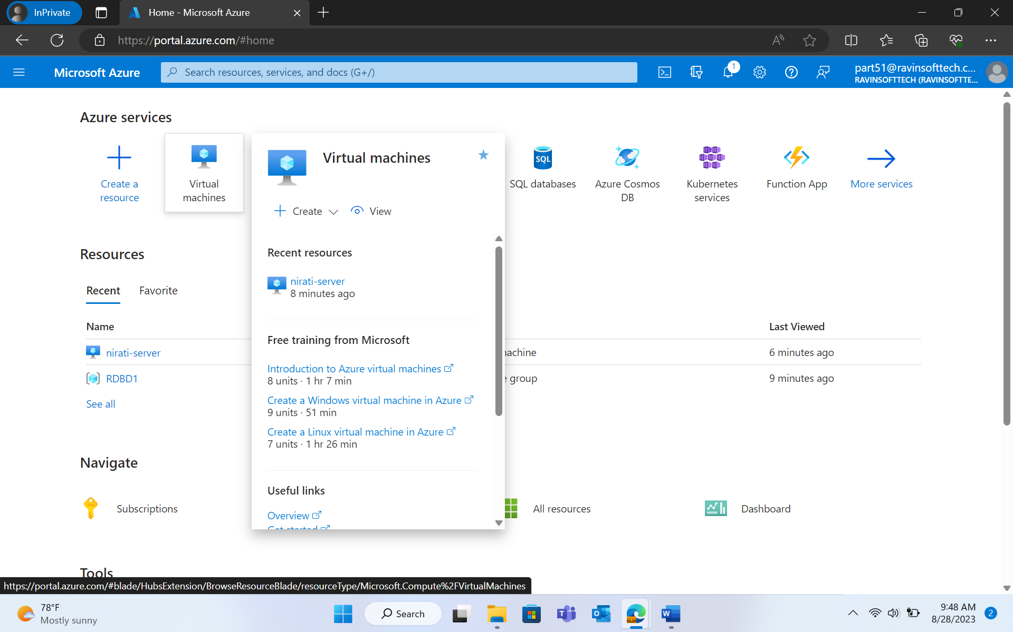

* Click on Create > Azure virtual machine.

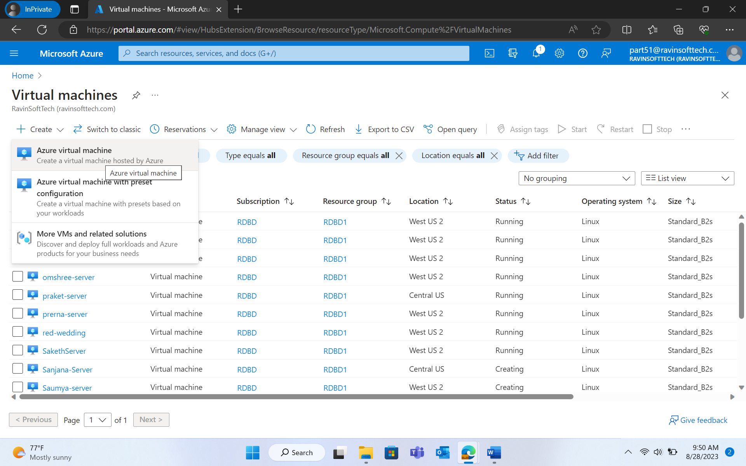

* Fill out the details

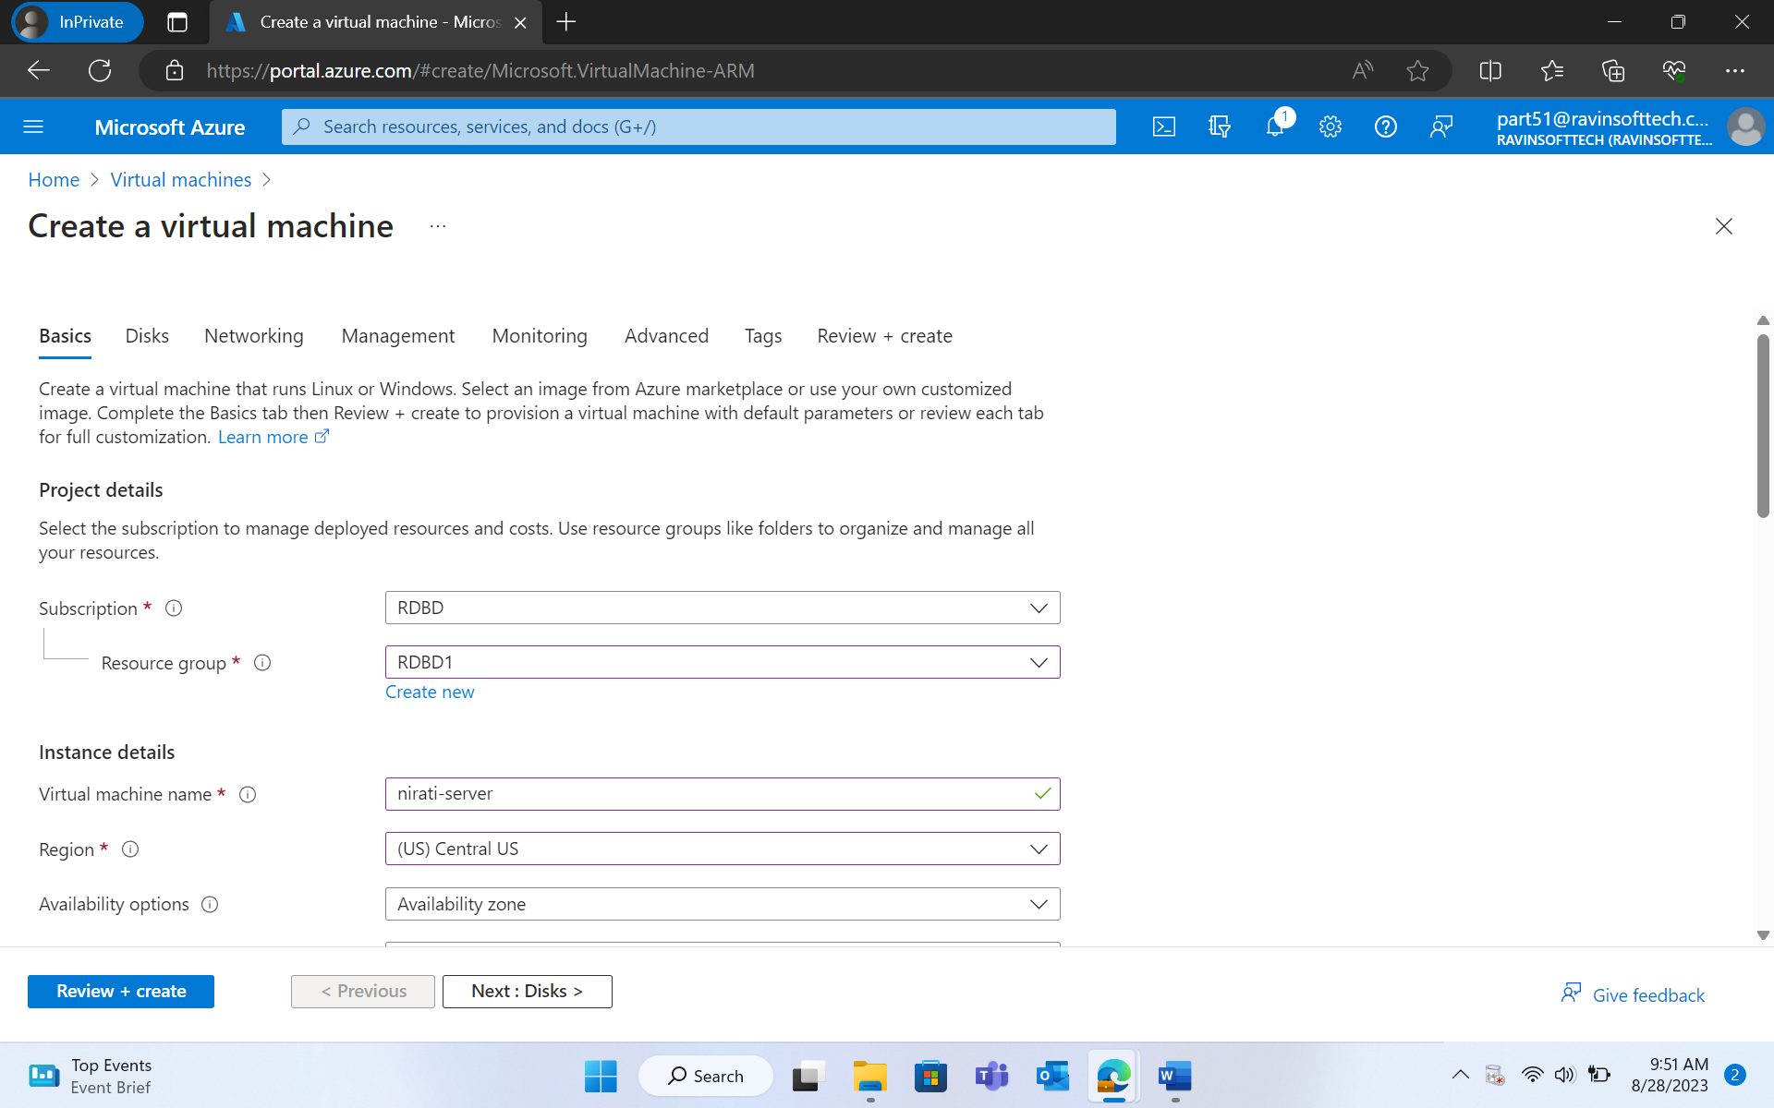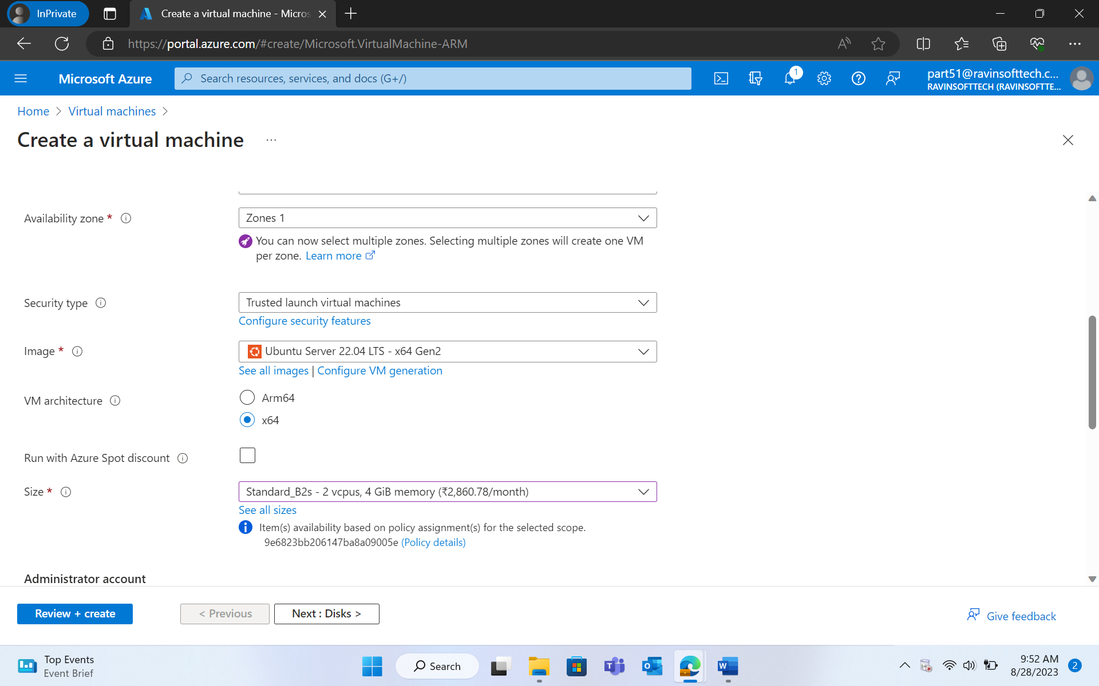

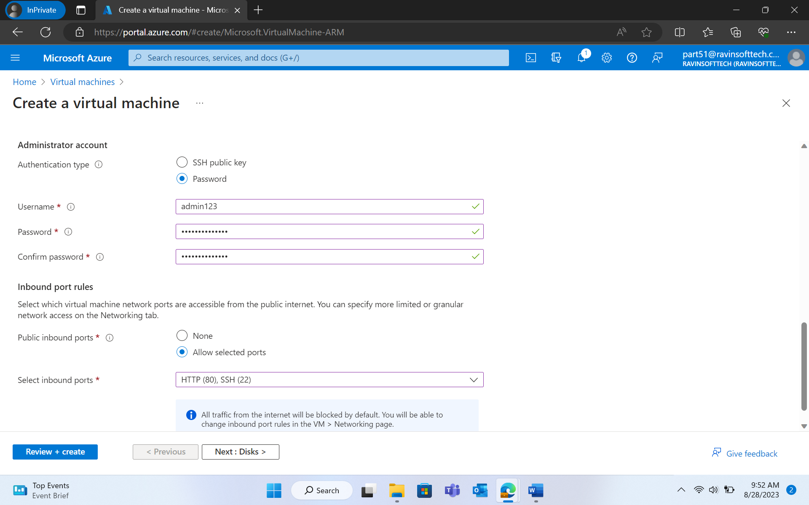

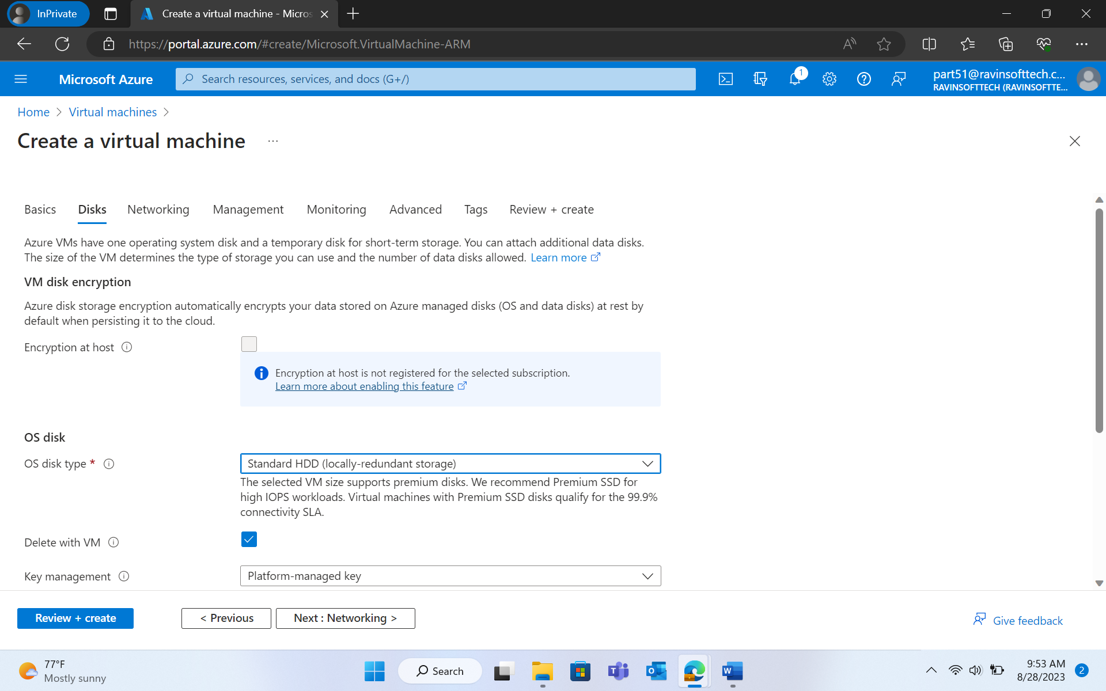

* Click on Review + create > Click on Create.

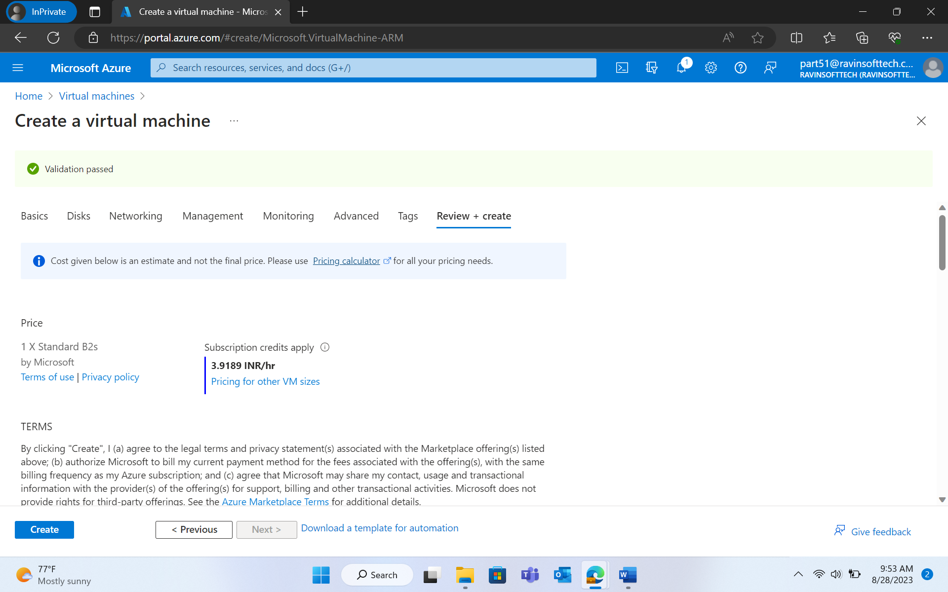

* It will take some time to complete the deployment.
* Once the deployment is completed, Virtual Machine is created.
* Now, click on "Go to resource". Note the Public IP address by scrolling down.

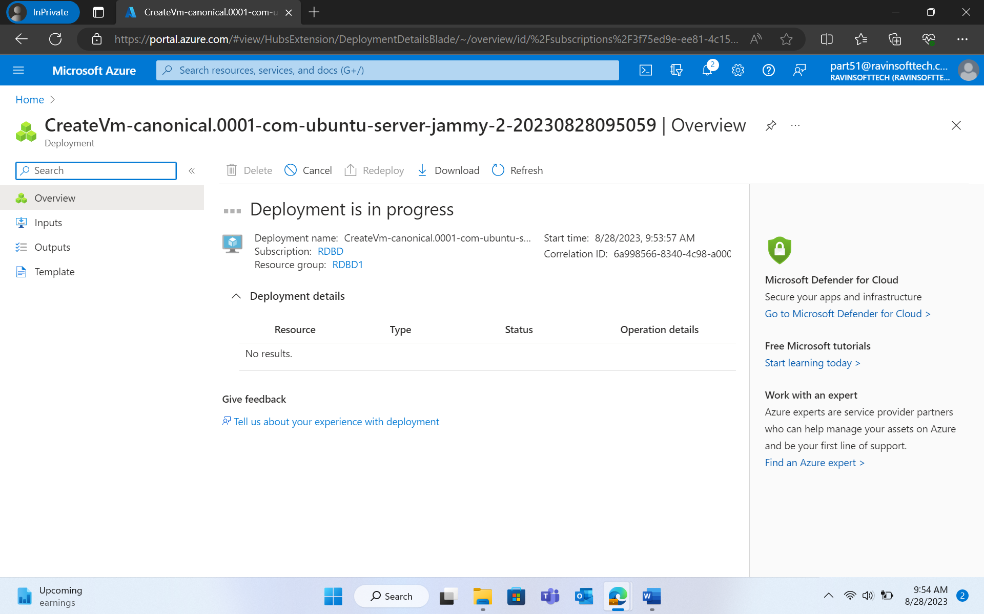

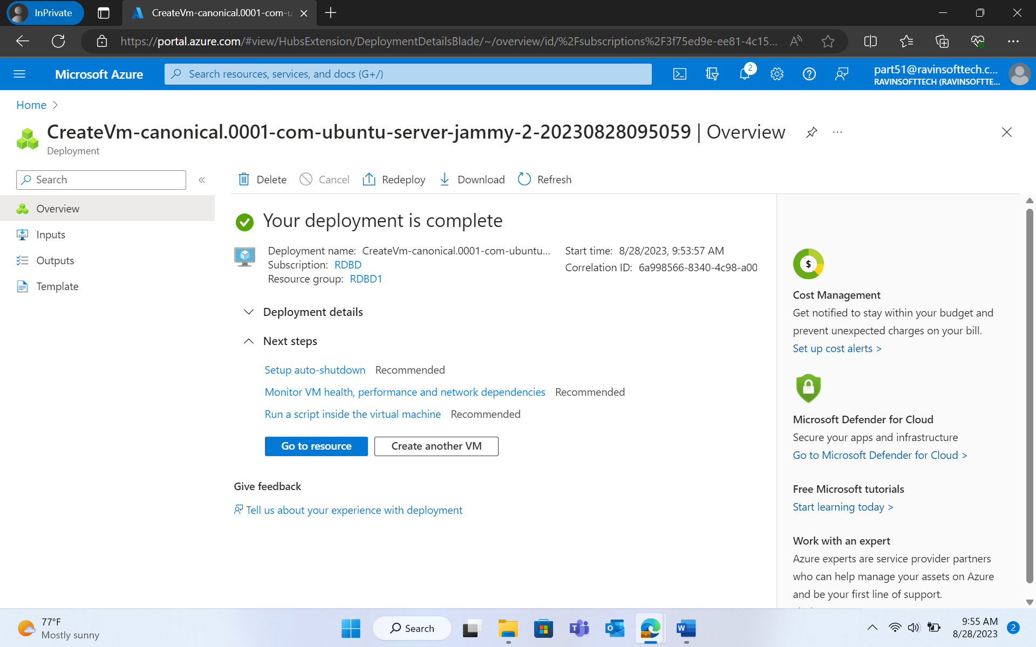

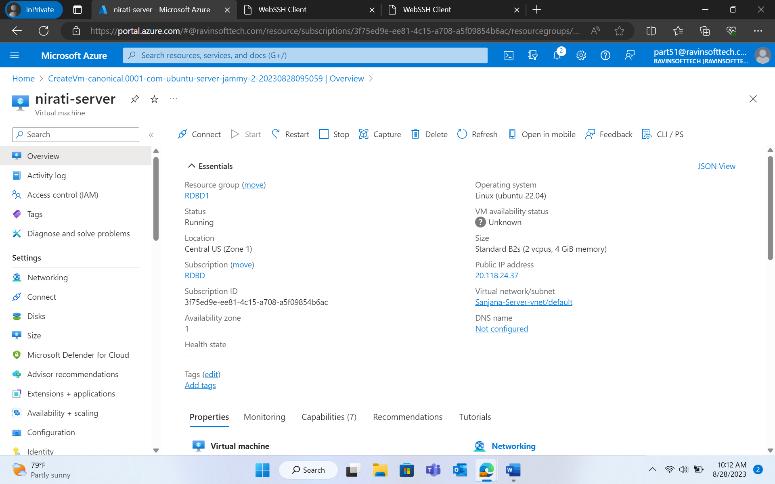

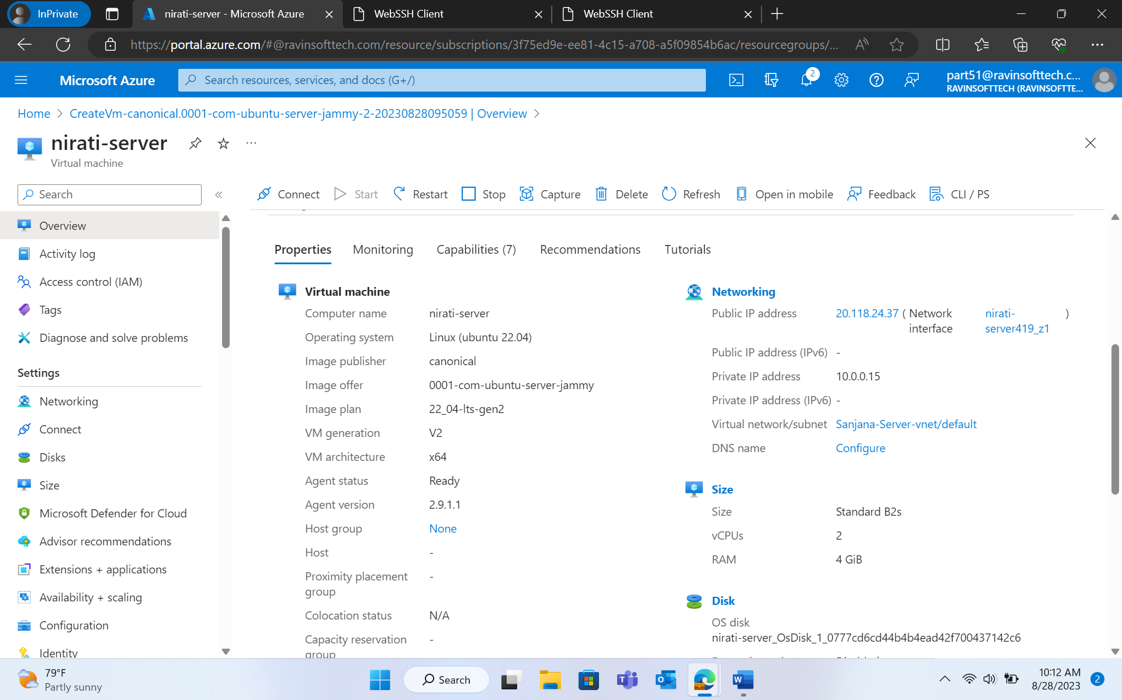

*Run commands on Azure Virtual Machine*

* Navigate to ssheasy.com
* Fill in the public ip address, username, and password. Click on "Connect".

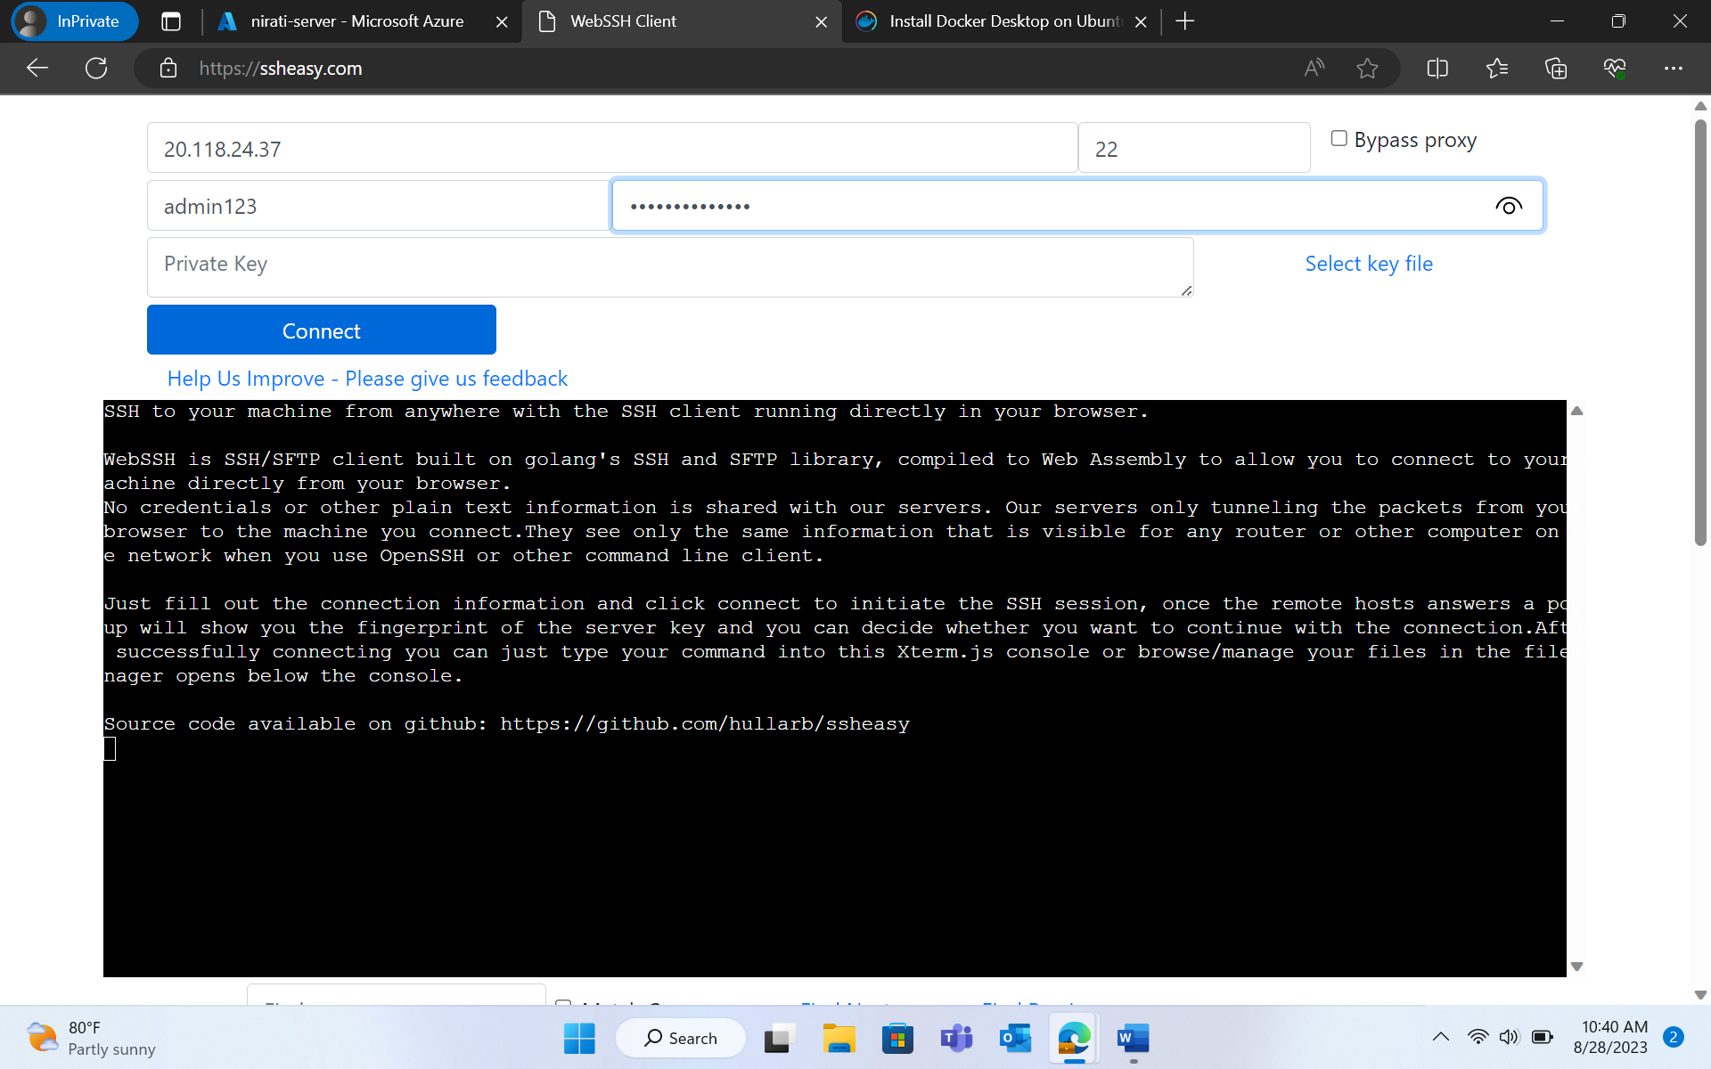

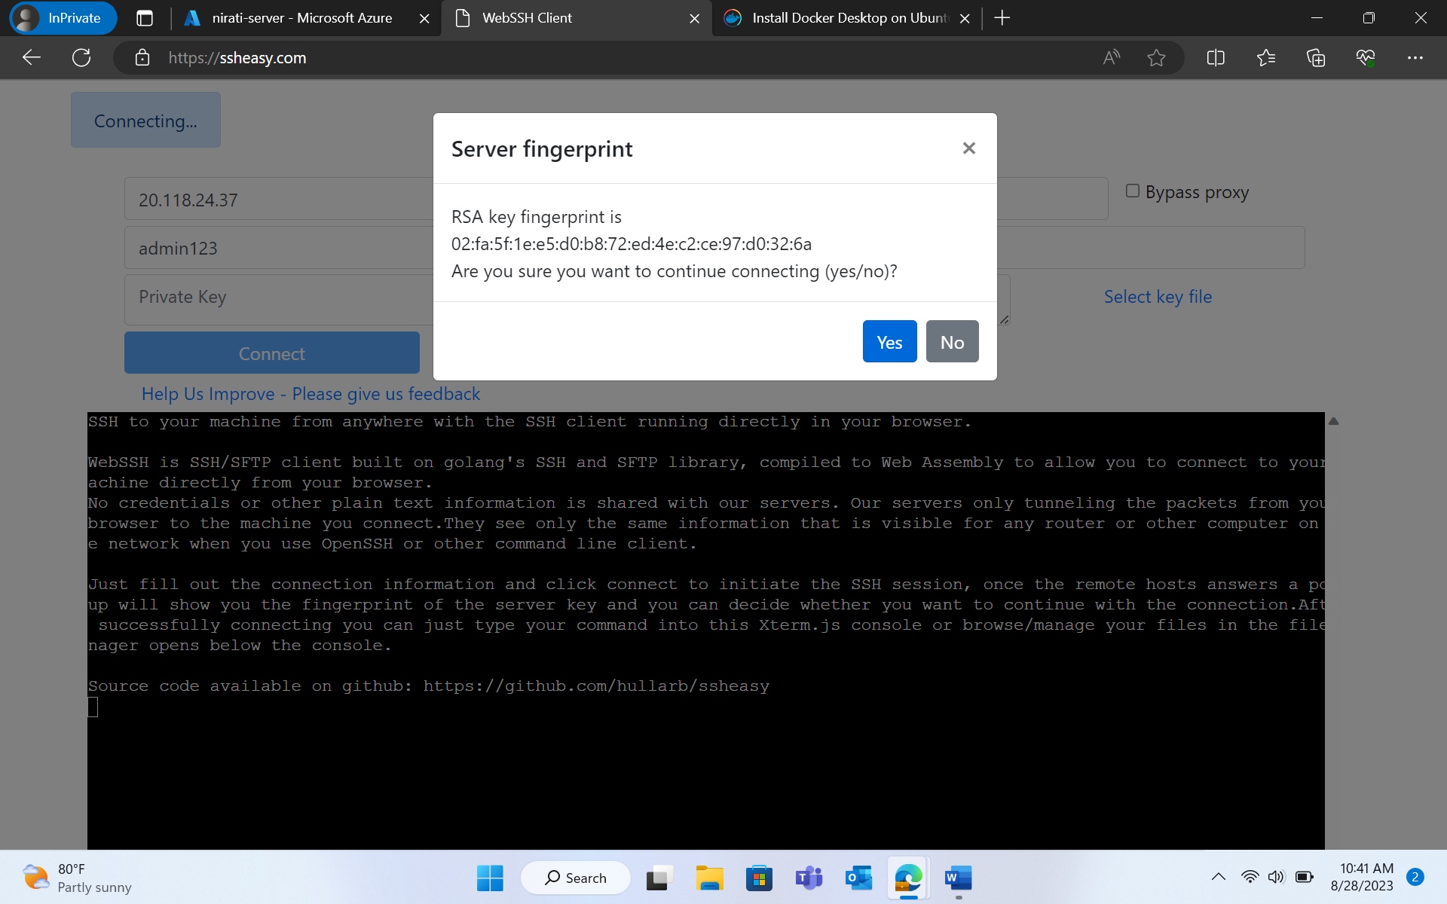

* Now, on the CLI, run the following commands:
* sudo apt install gnome-terminal

**SETTING UP THE DOCKER REPOSITORY**

* sudo apt-get update
* sudo apt install git
* sudo apt install maven
* sudo apt-get install ca-certificates curl gnupg
* sudo install -m 0755 -d /etc/apt/keyrings
* sudo curl -fsSL https://download.docker.com/linux/ubuntu/gpg | sudo gpg --dearmor -o /etc/apt/keyrings/docker.gpg
* sudo chmod a+r /etc/apt/keyrings/docker.gpg
* echo \

"deb [arch="$(dpkg --print-architecture)" signed-by=/etc/apt/keyrings/docker.gpg] https://download.docker.com/linux/ubuntu \

"$(. /etc/os-release && echo "$VERSION_CODENAME")" stable" | \

sudo tee /etc/apt/sources.list.d/docker.list > /dev/null

* sudo apt-get update

**INSTALLING DOCKER ENGINE**

* sudo apt-get install docker-ce docker-ce-cli containerd.io docker-buildx-plugin docker-compose-plugin
* sudo docker run hello-world

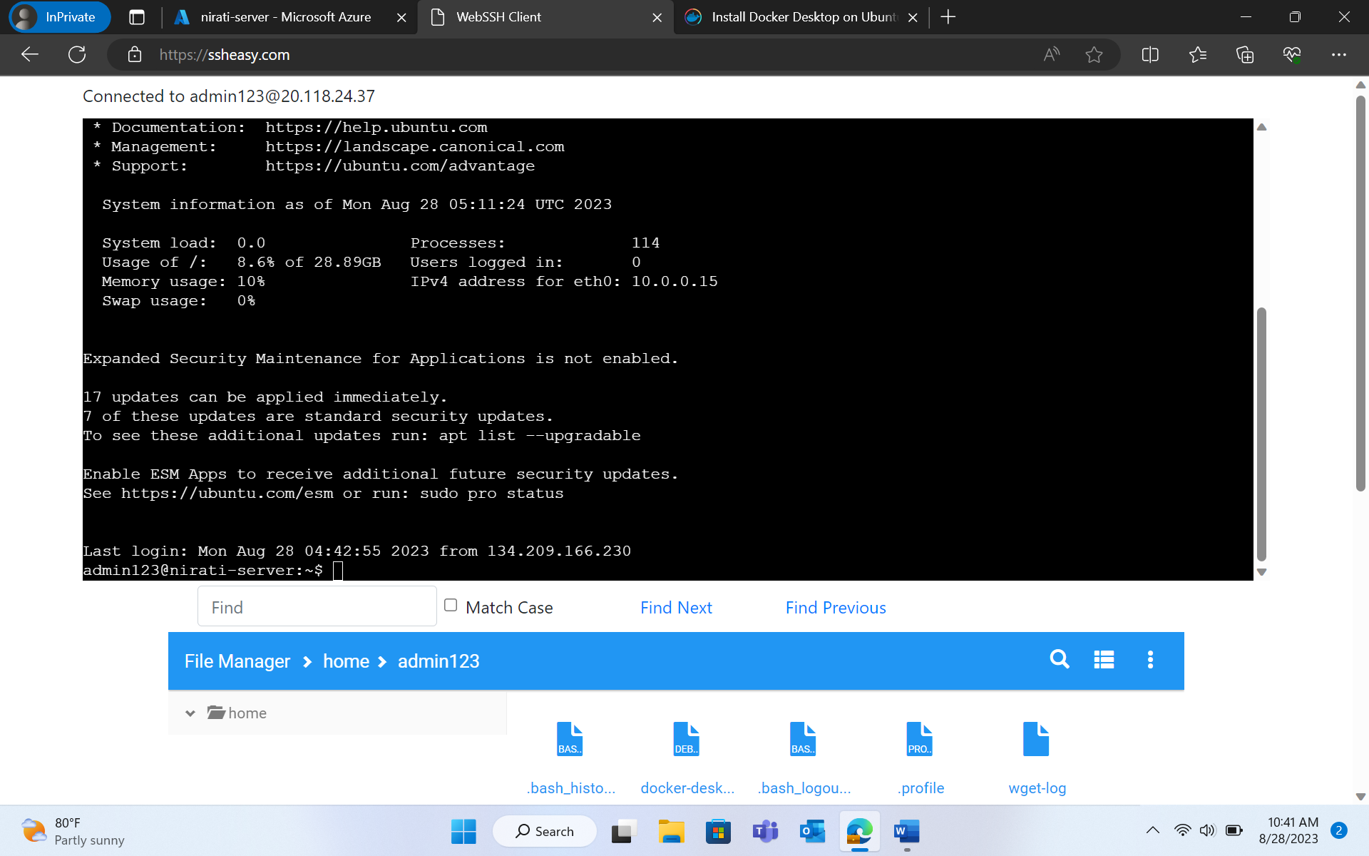

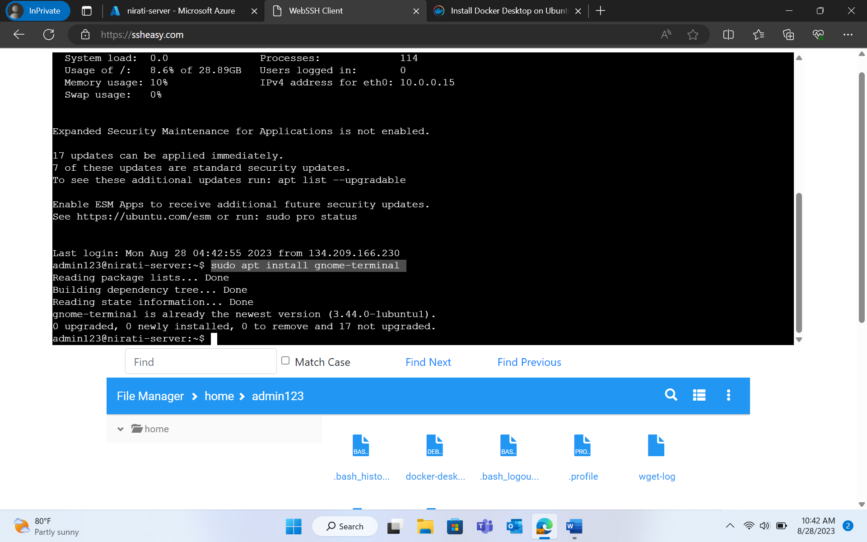

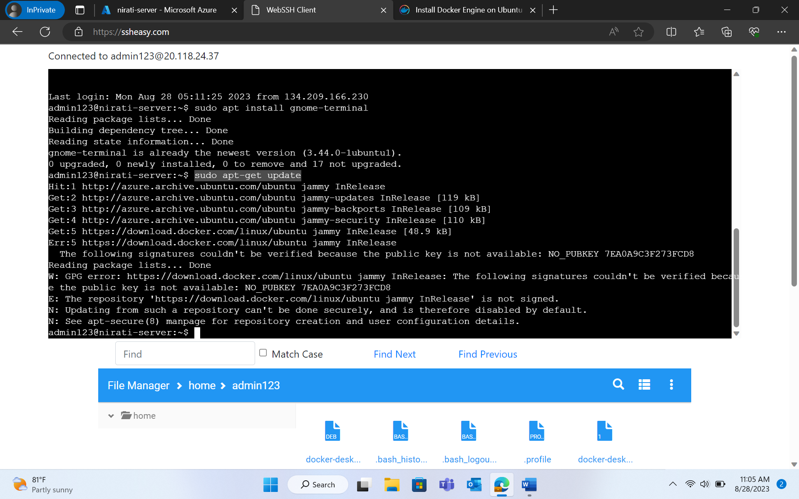

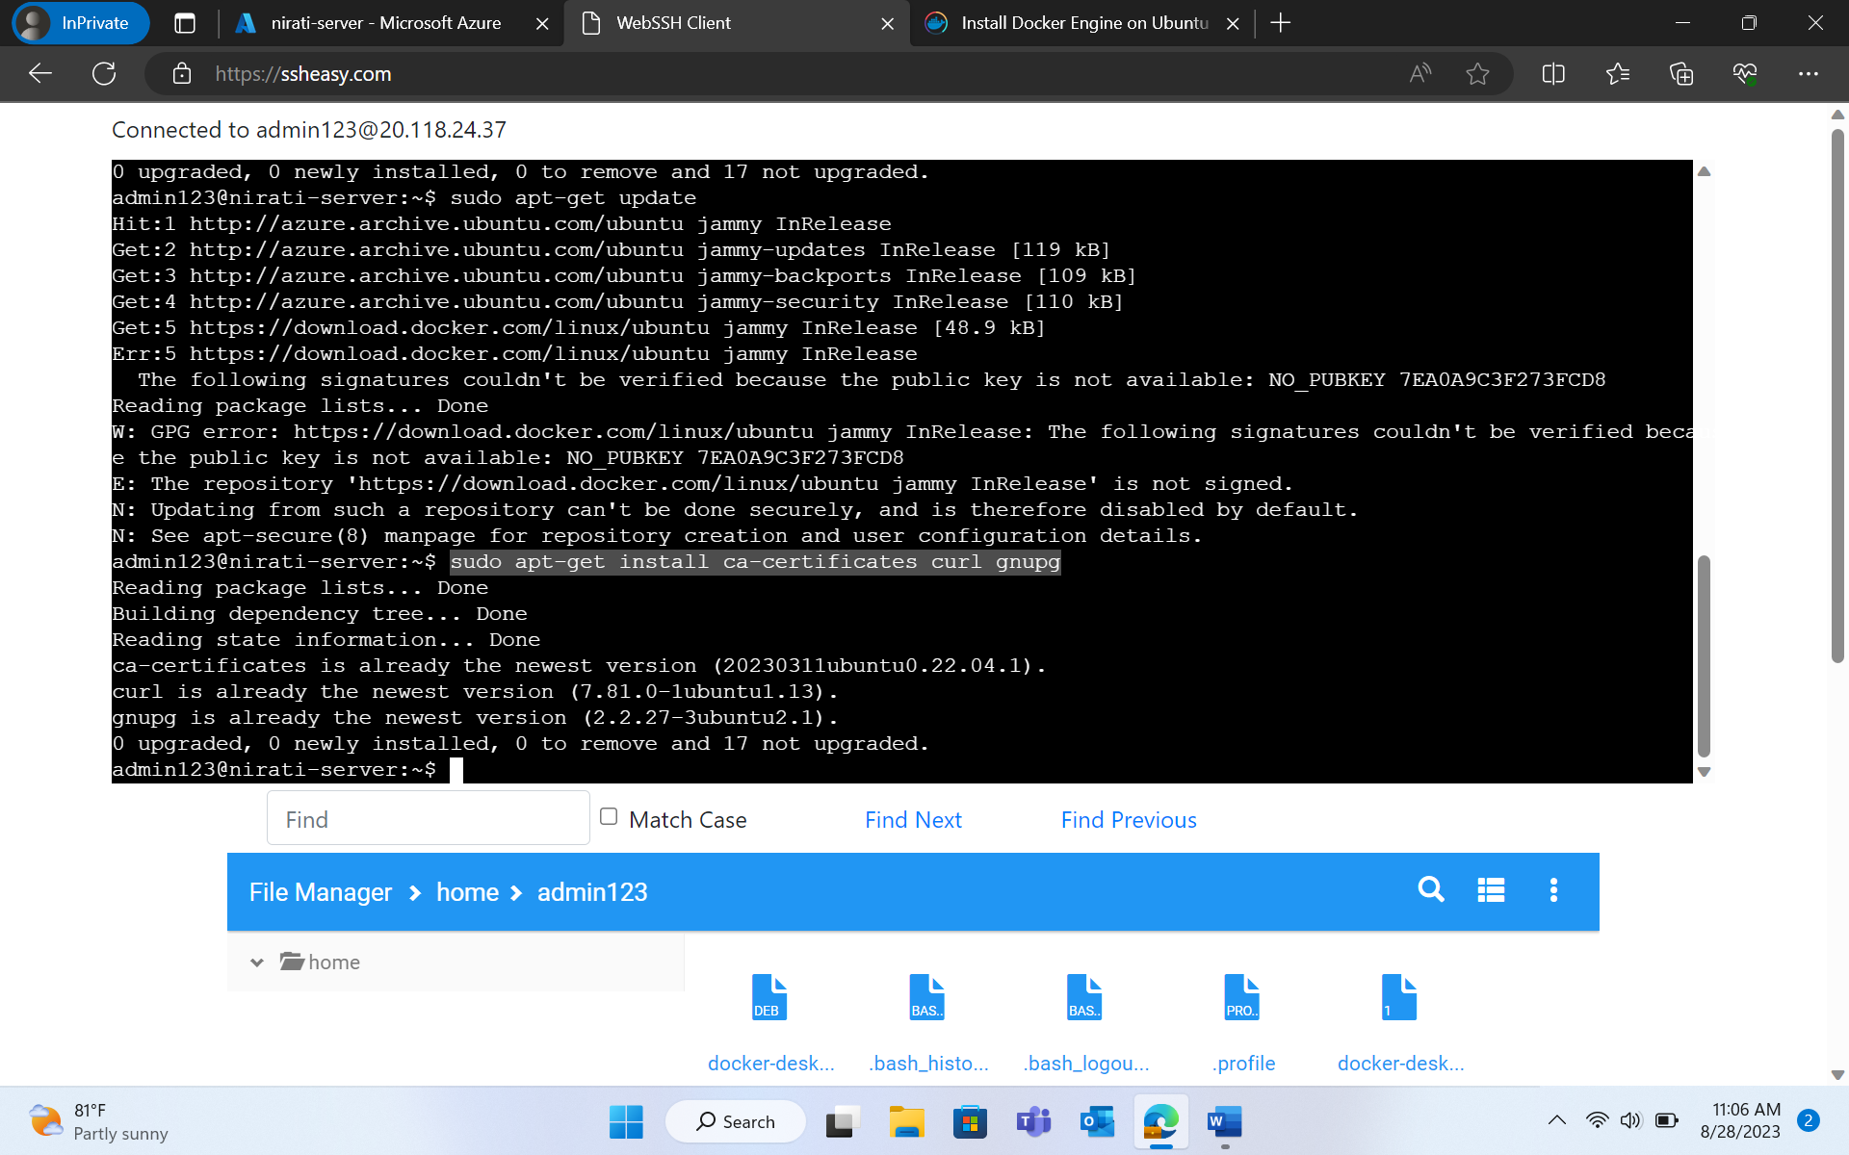

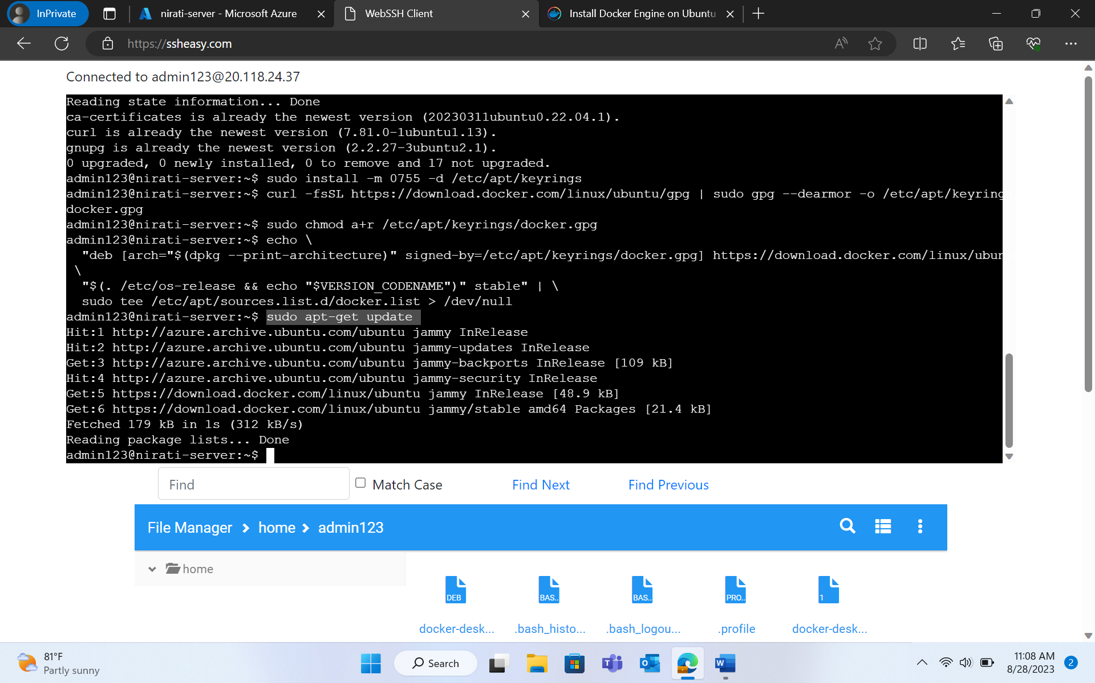

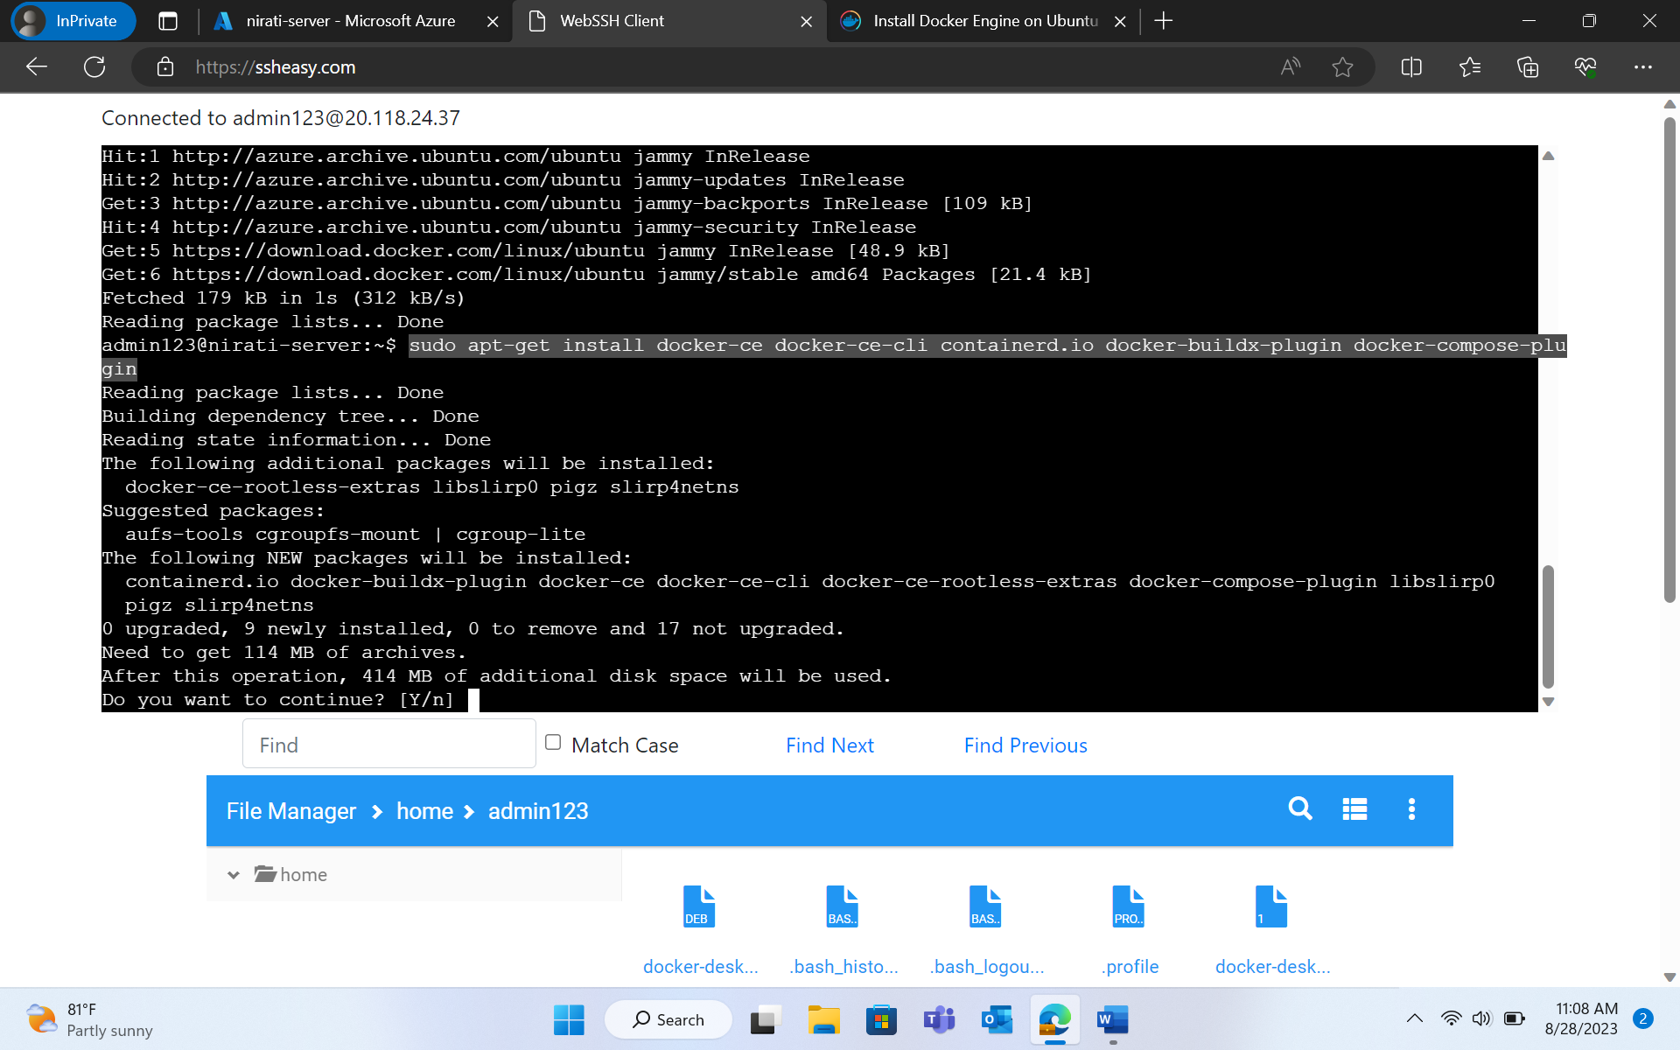

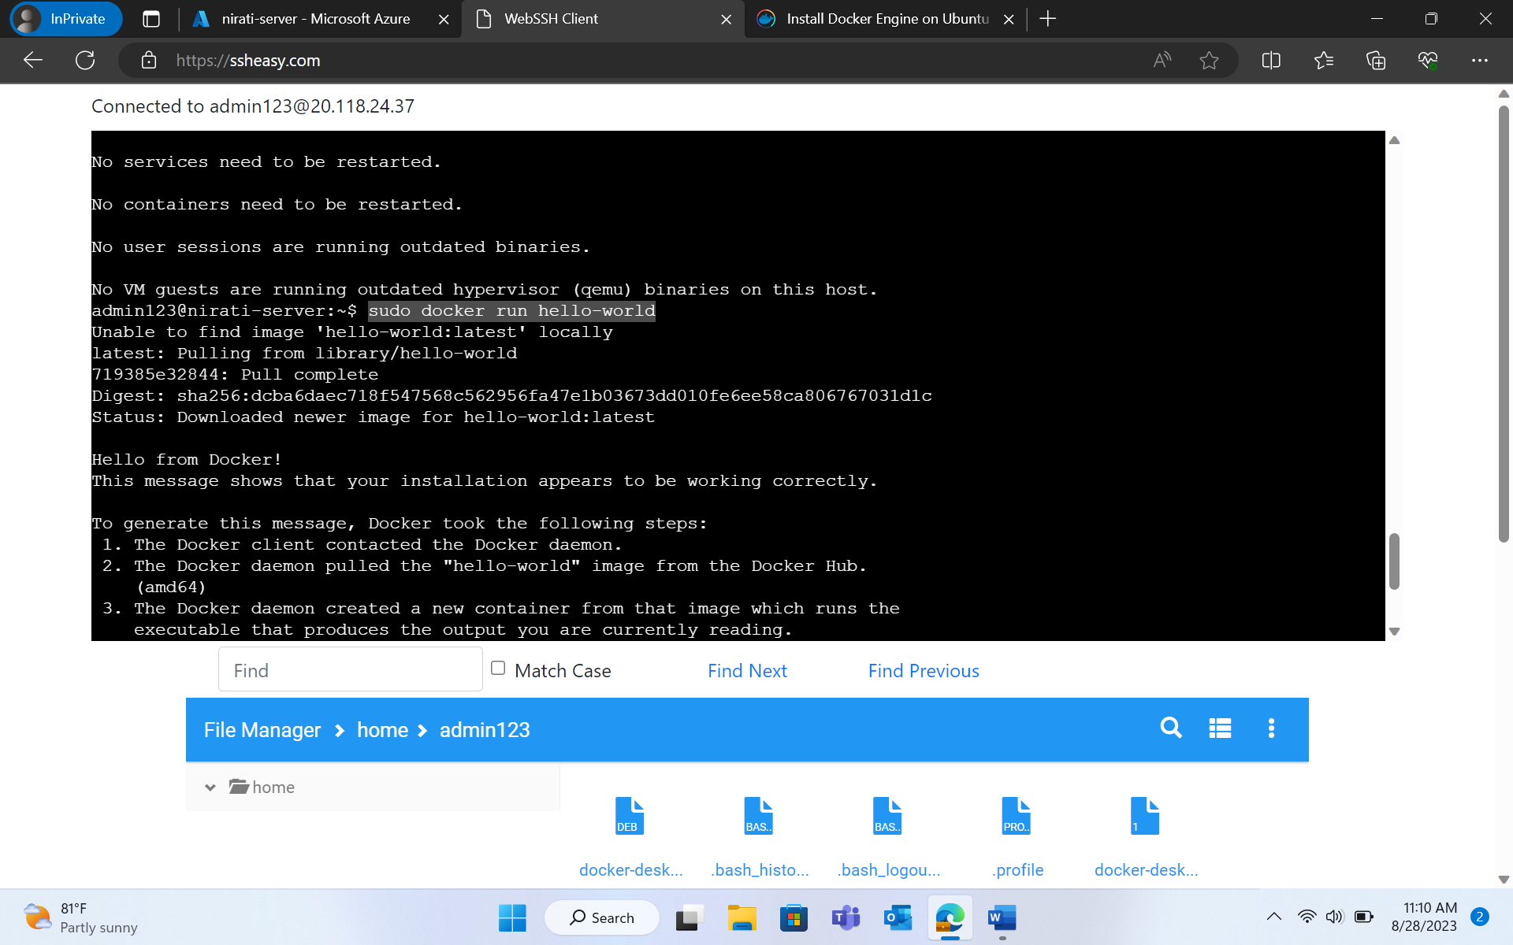

**DOWNLOADING LATEST DEB PACKAGE**

* sudo wget [LINK] (link of DEB package)
* Press Ctrl+C - to kill the command after few seconds.

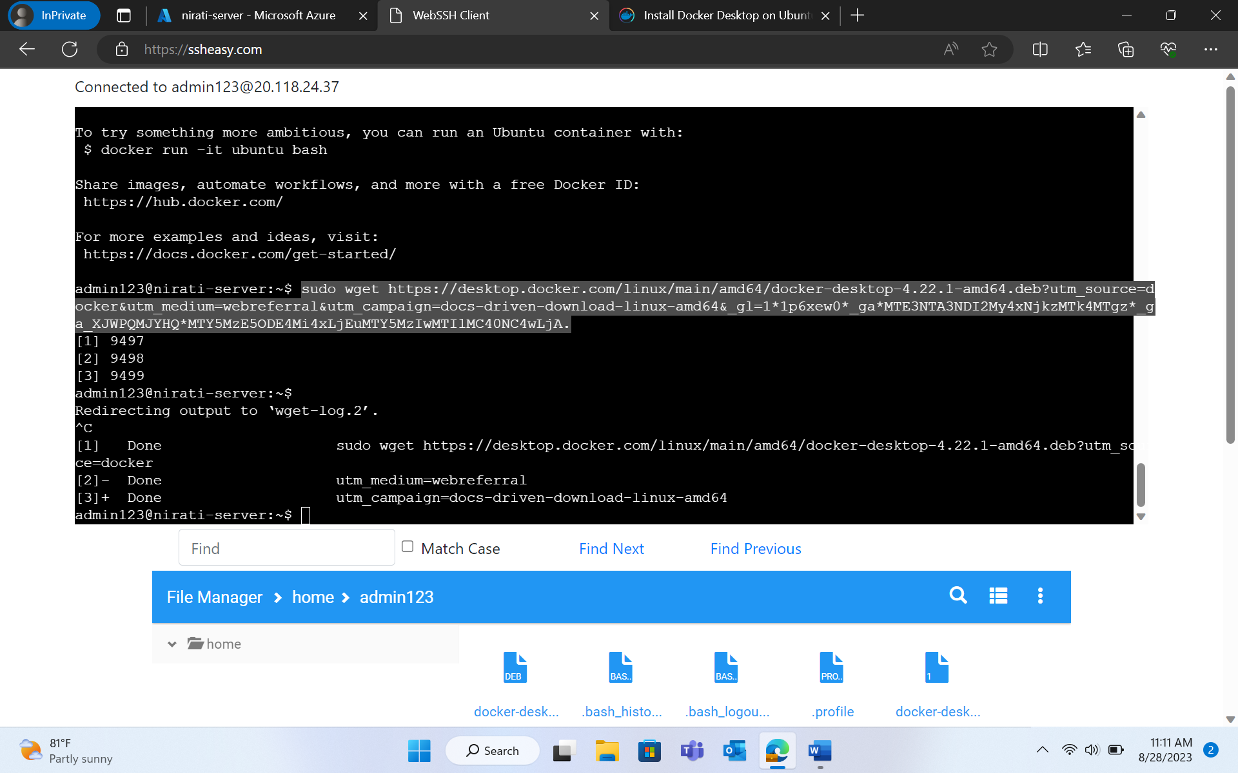

* ls -l
* sudo mv 'docker-desktop-4.22.1-amd64.deb?utm_source=docker' docker-desktop-4.22.1-amd64.deb
* ls -l
* sudo apt-get update

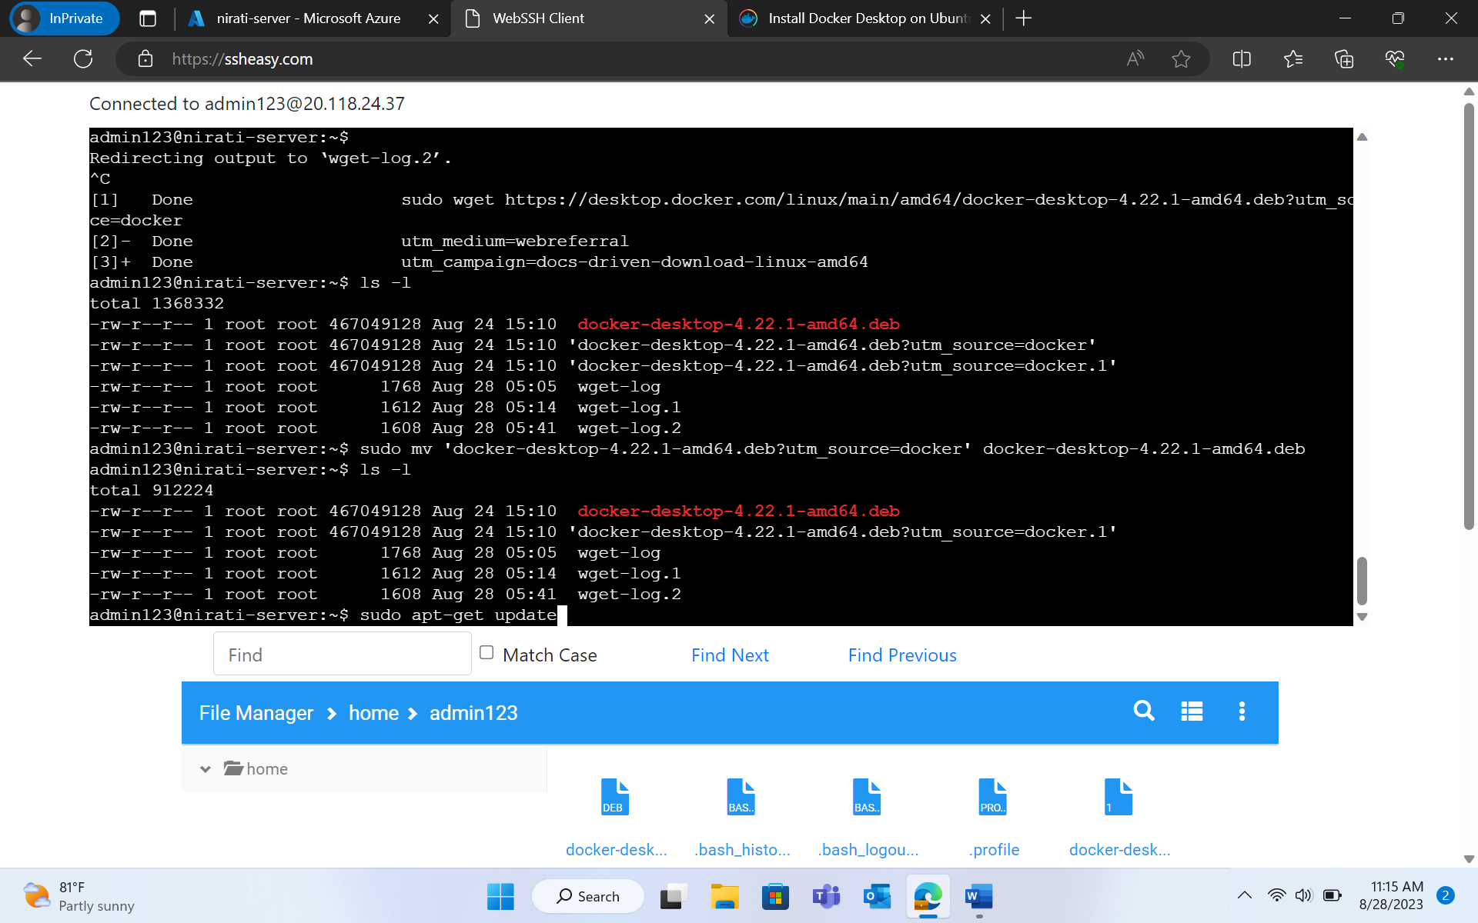

* sudo apt-get install ./docker-desktop-4.22.1-amd64.deb

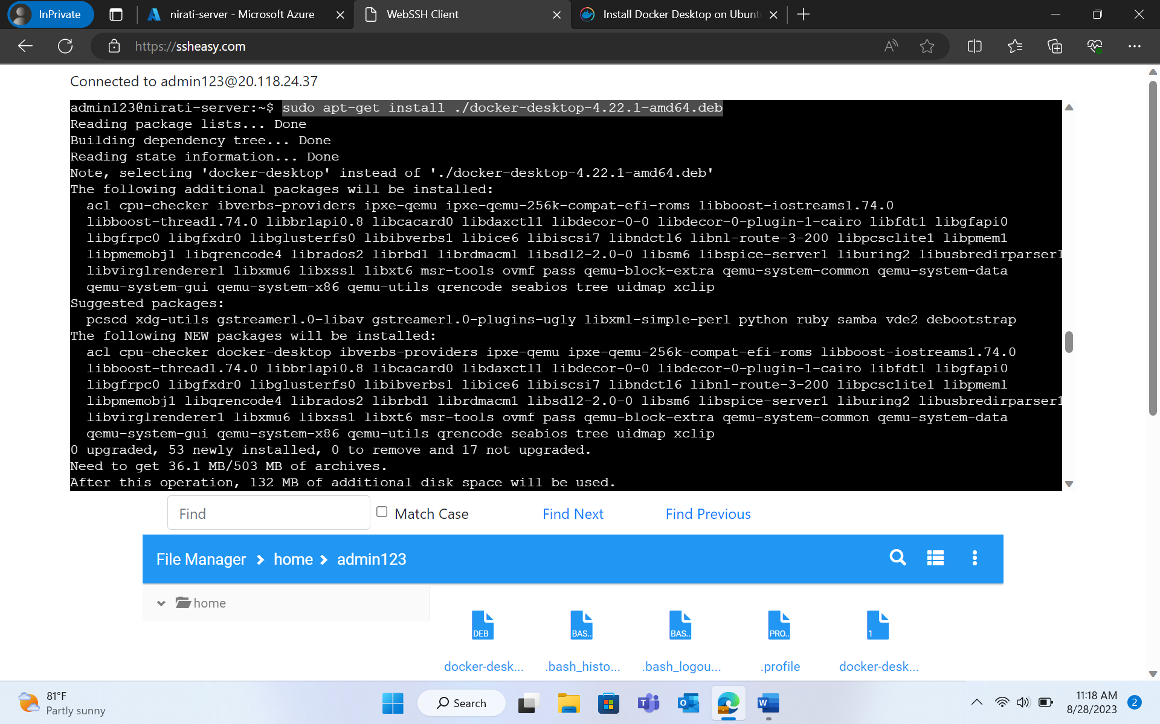

**LAUNCHING DOCKER DESKTOP**

* systemctl --user start docker-desktop
* systemctl --user enable docker-desktop

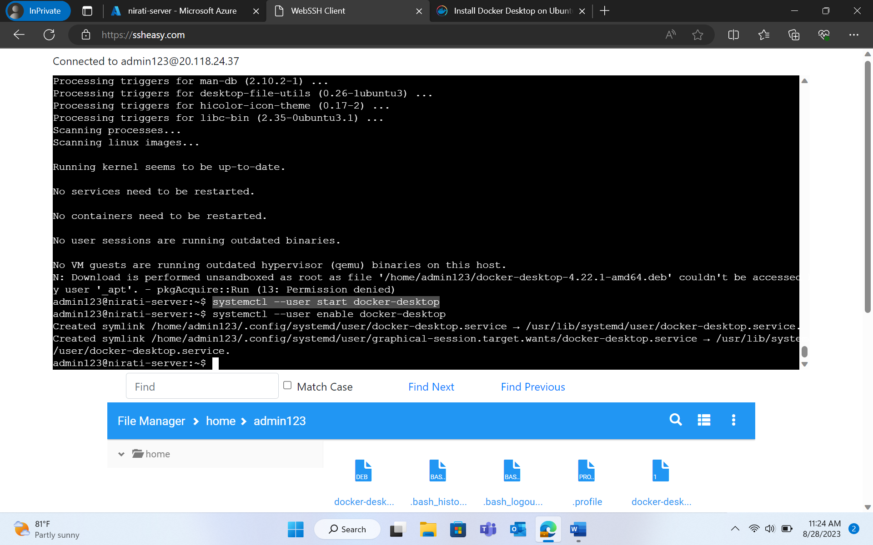

**CLONING THE APPLICATION TO OUR LOCAL DEVELOPMENT MACHINE**

* git clone https://github.com/spring-projects/spring-petclinic.git
* cd spring-petclinic

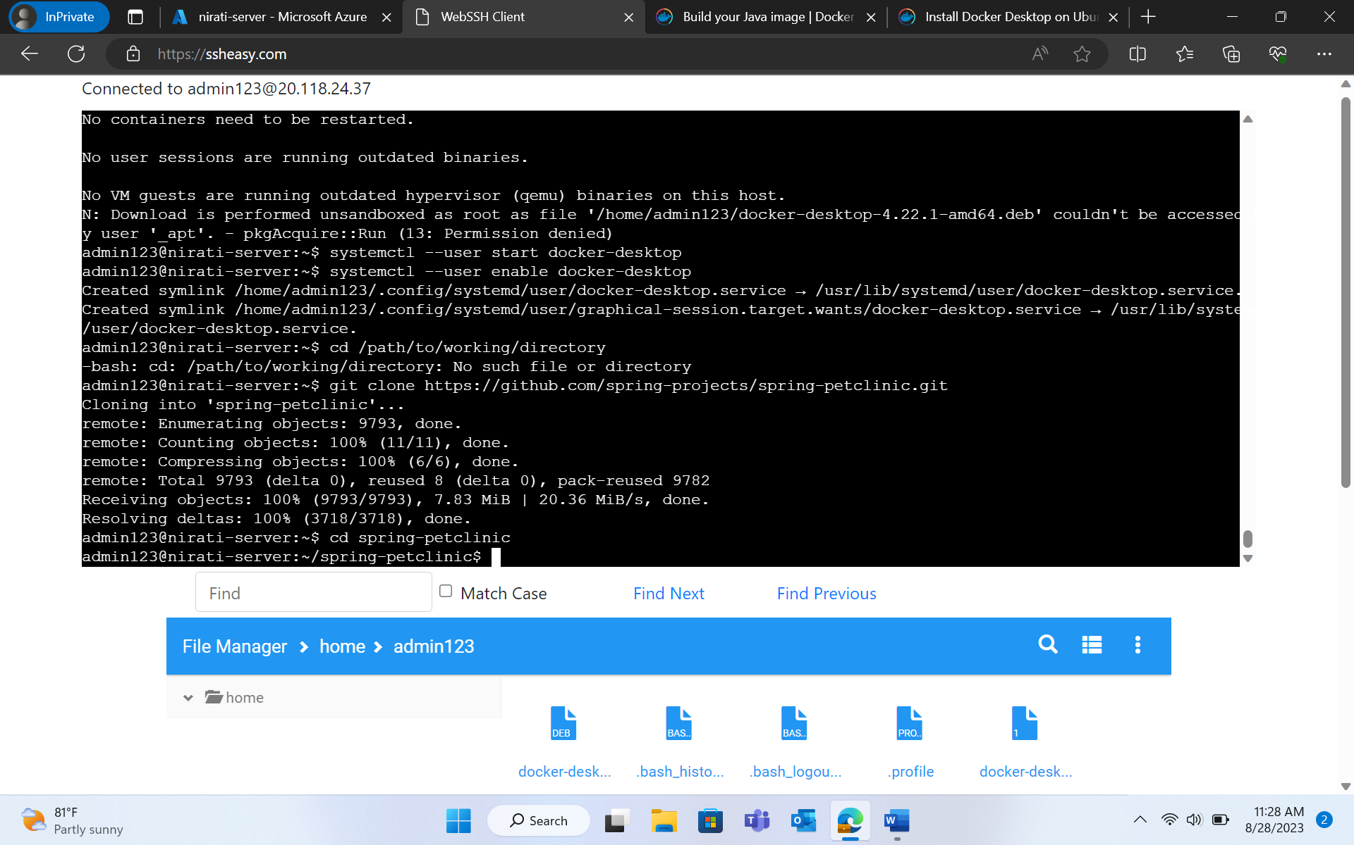

**CREATING THE DOCKERFILE FOR JAVA**

* touch dockerfile
* nano dockerfile
* Paste the code for ()
* cat dockerfile

**CREATING .dockerignore FILE**

* touch .dockerignore
* nano .dockerignore
* Type target > ctrl+s > ctrl+x

**BUILDING FIRST DOCKER IMAGE**

* docker build --tag java-docker

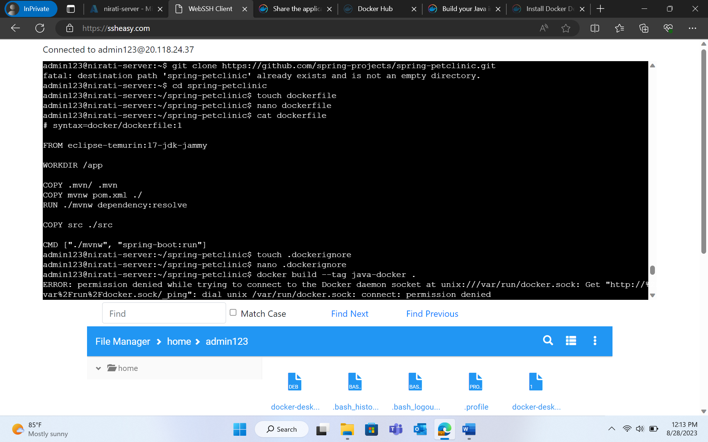

**CREATING A REPOSITORY ON DOCKER HUB**

* Sign up to DockerHub
* Select “Create Repository” button.
* Name the repository as “getting-started”. Check that the Visibility is Public.
* Click on “Create”

ON CLI (ssheasy.com)

* After creating repository on DockerHub, type following commands on CLI:
  + sudo docker login -u [username]
  + Type your password
  + sudo docker tag java-docker:latest [username]/getting-started
  + sudo docker push [username]/getting-started

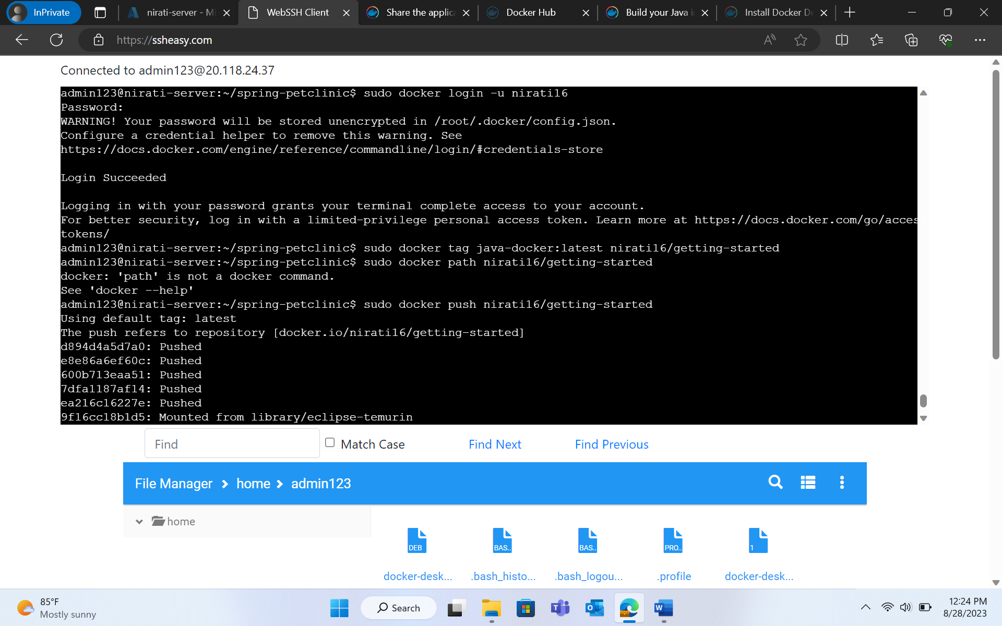

**The dockerhub:**

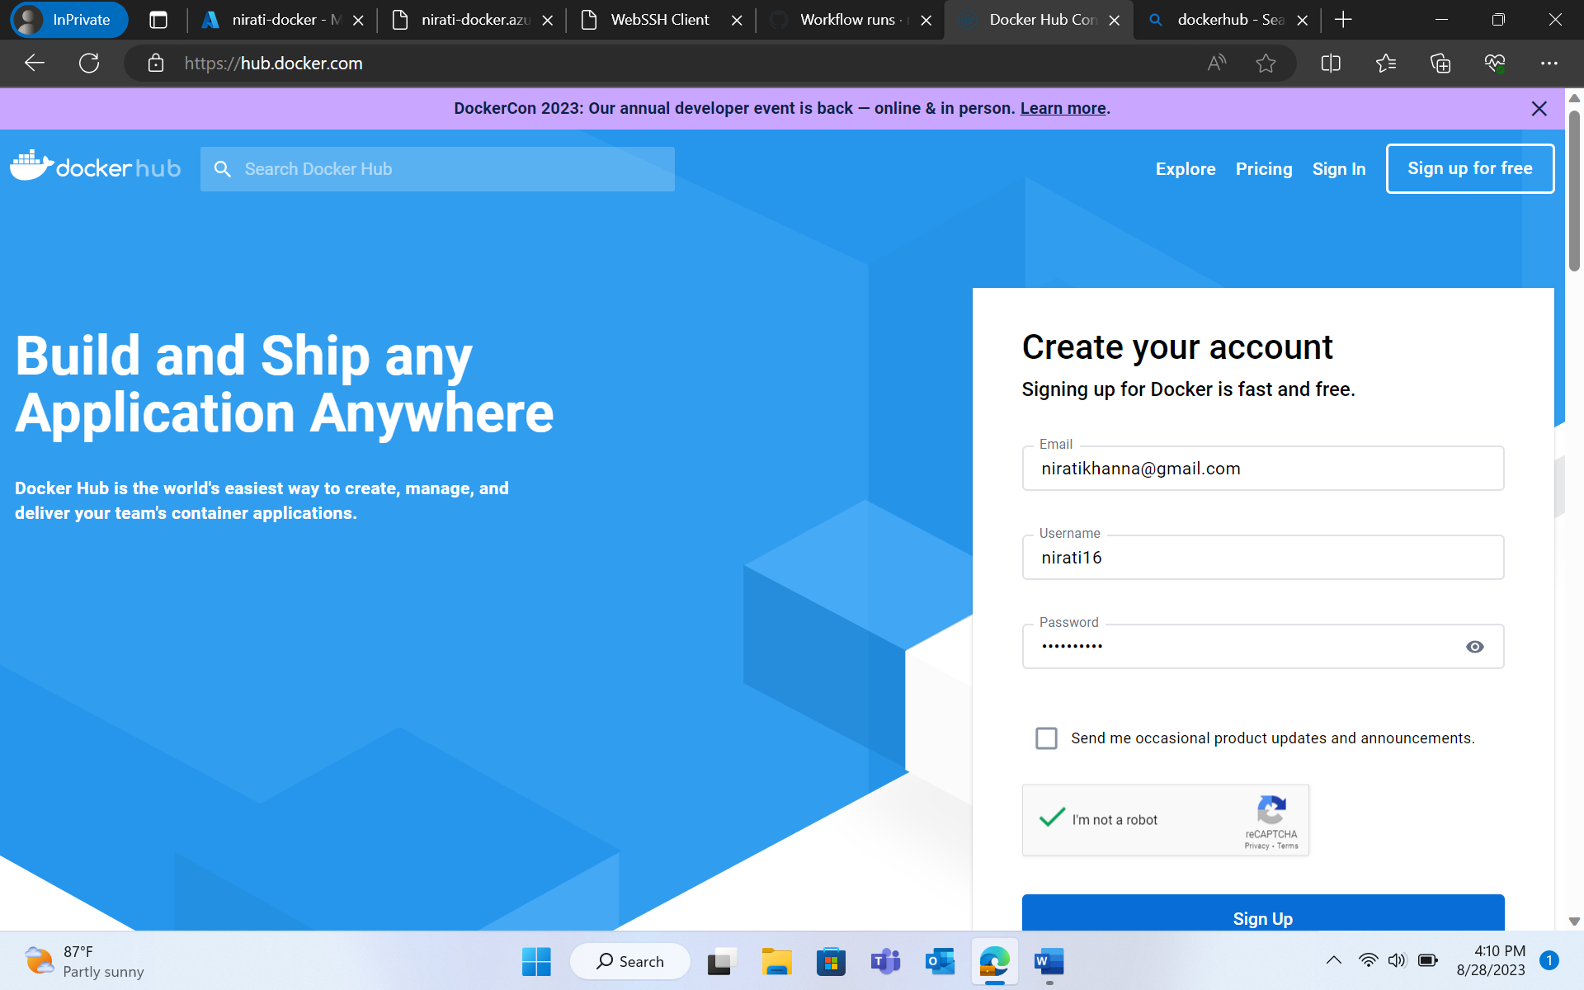

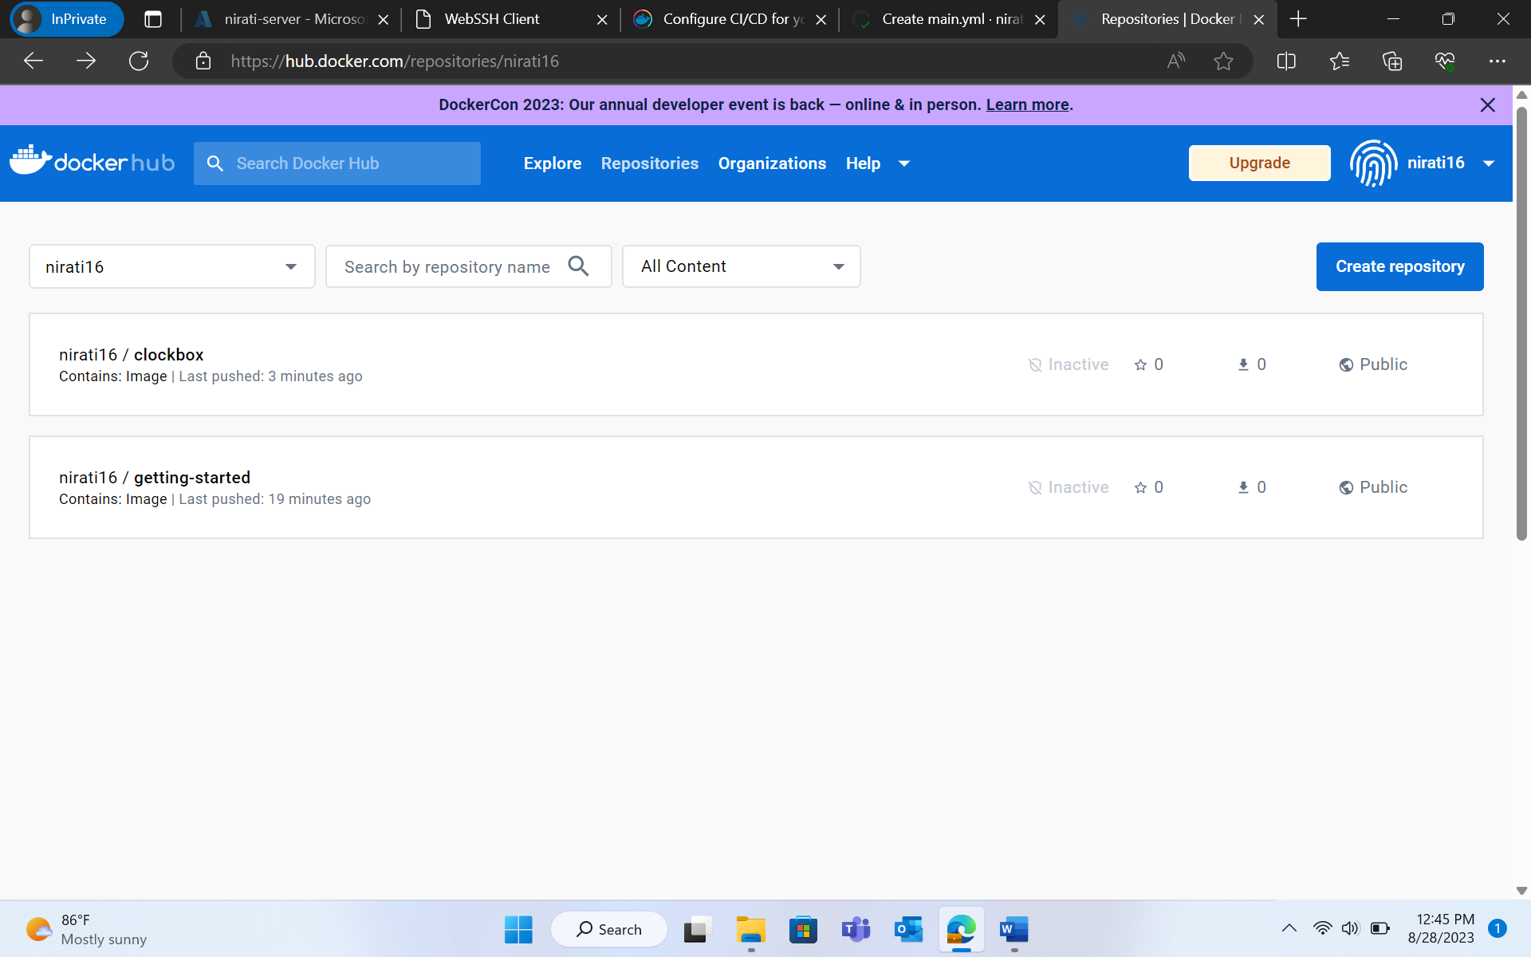

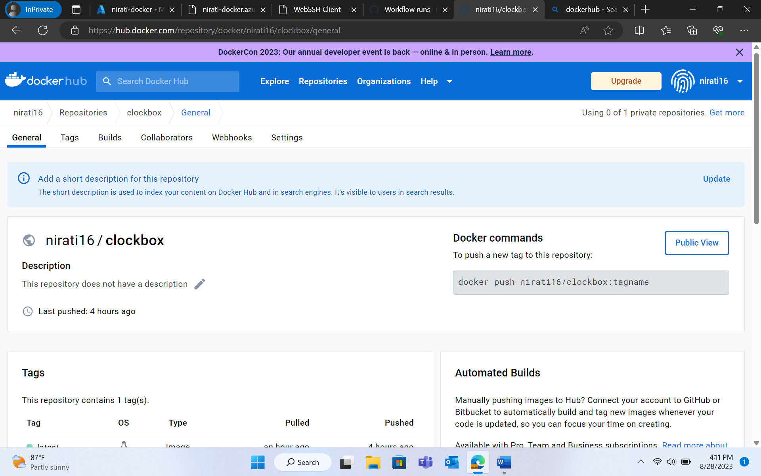

*Create azure web app*

**CREATING WEB APP**

* Search App Services on Microsoft Azure.
* Click on Create > Web App.
* Fill the details.
* Click on Review + Create > Create.

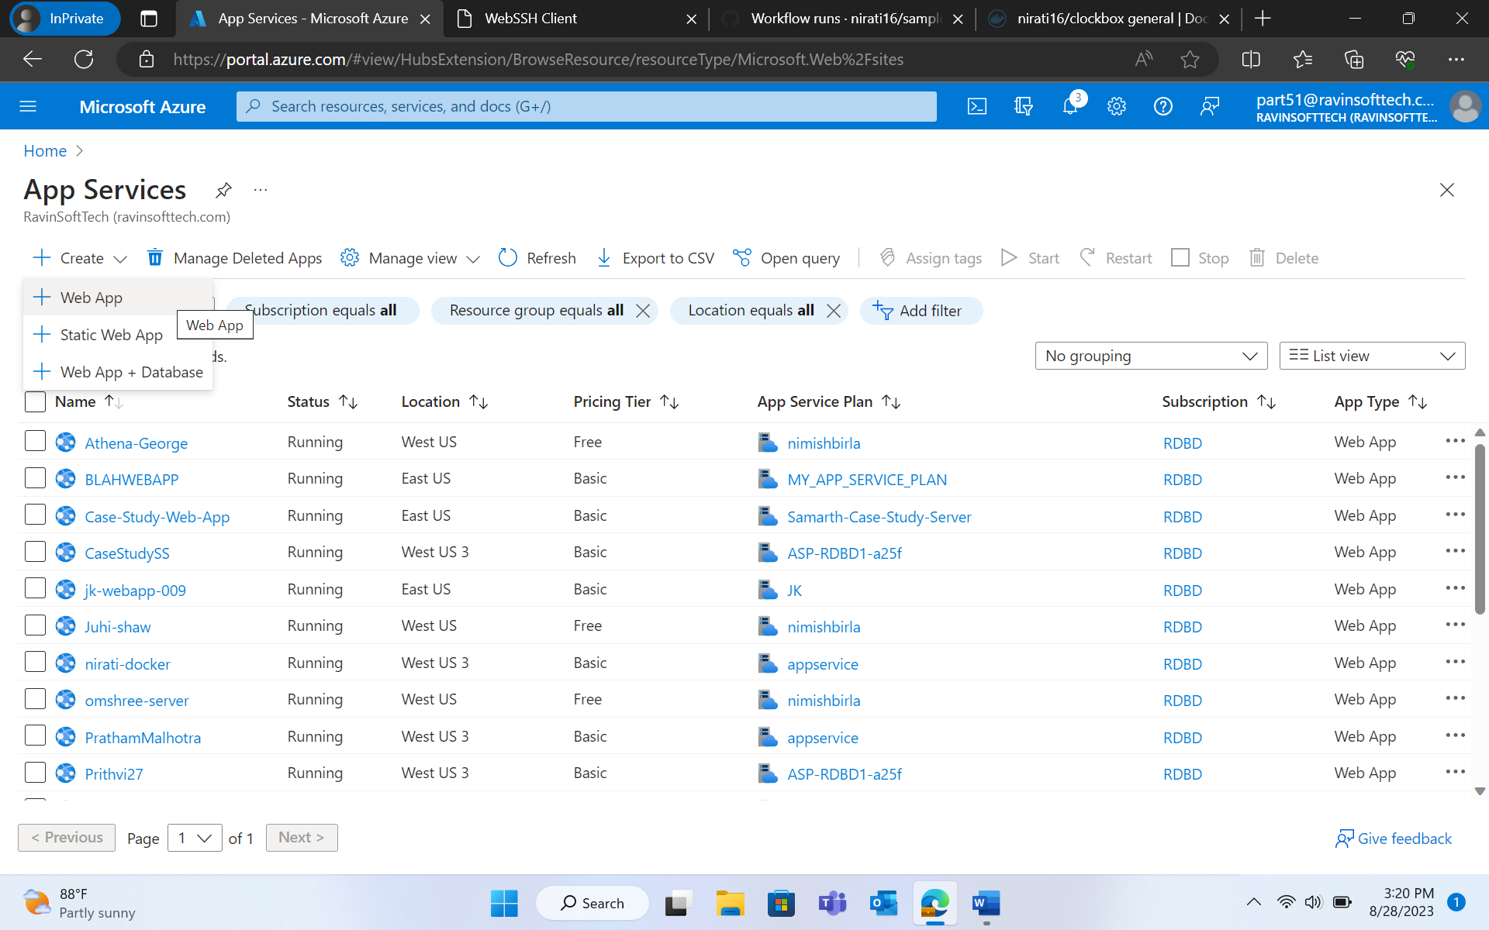

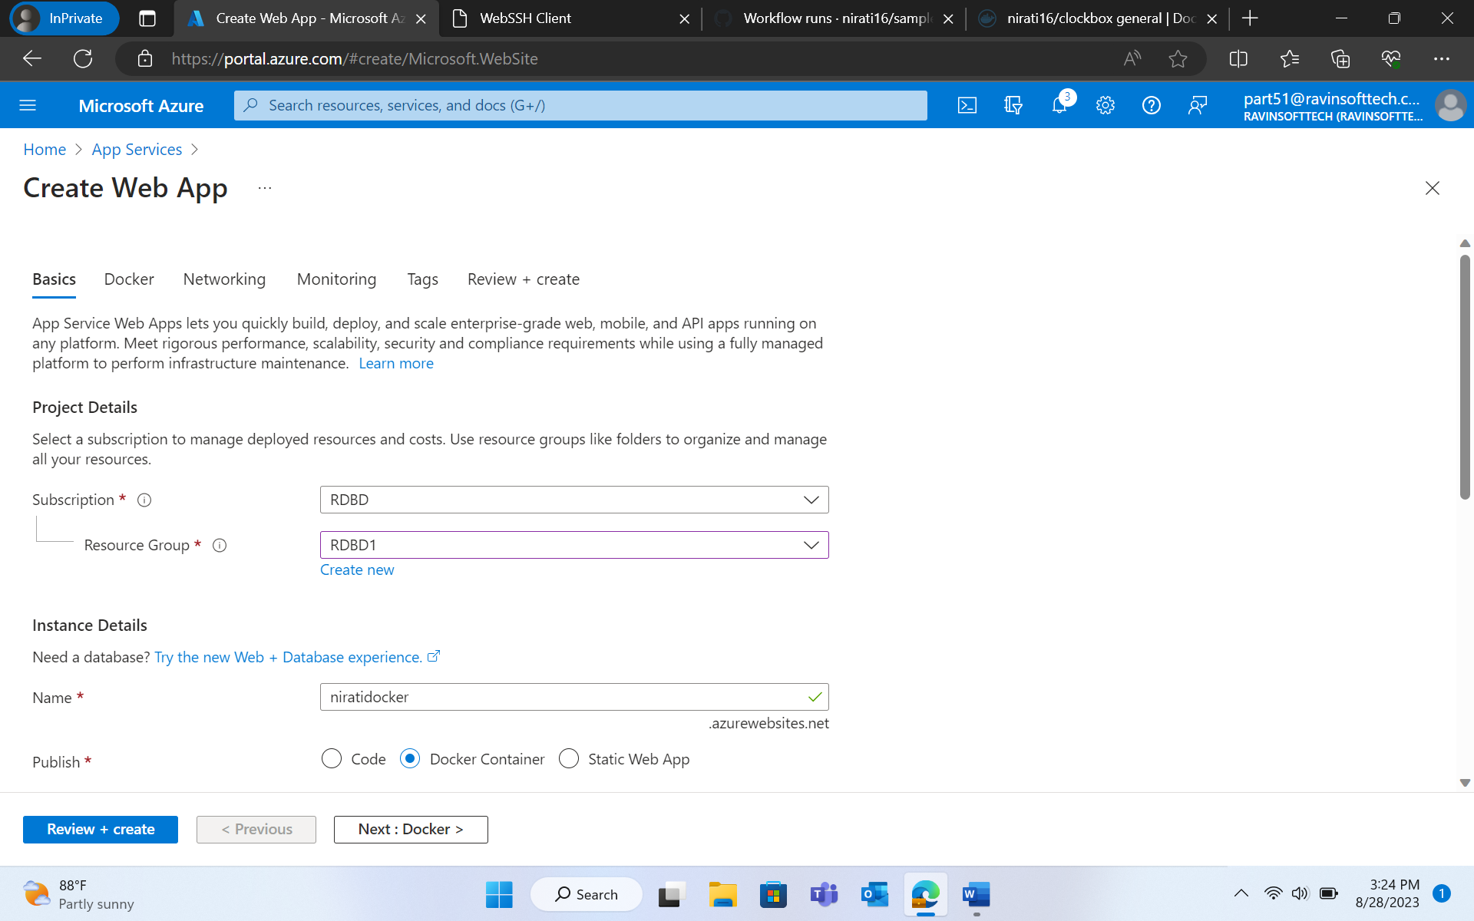

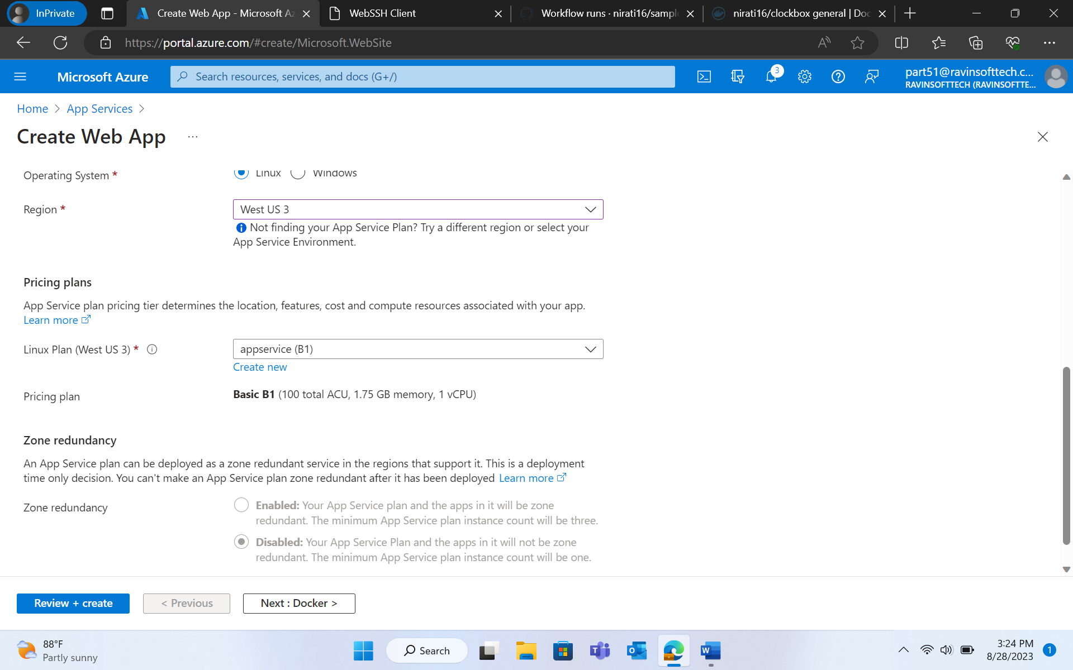

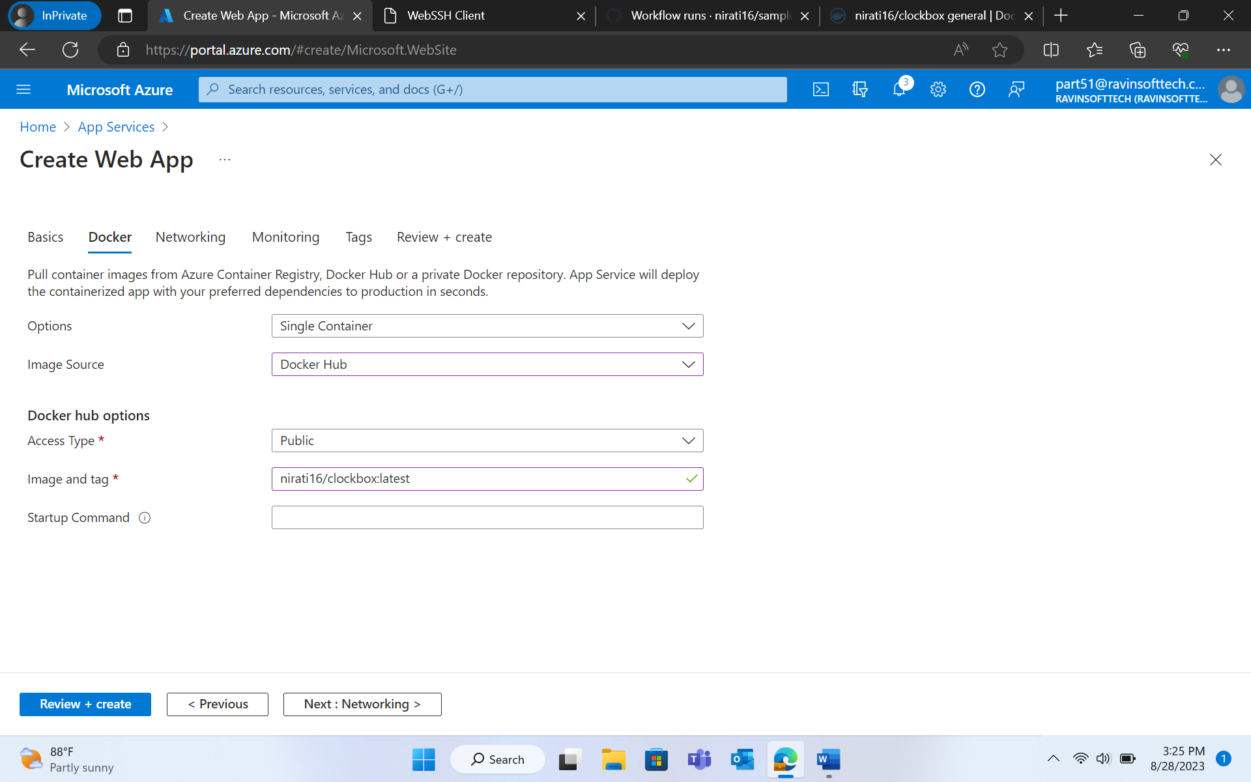

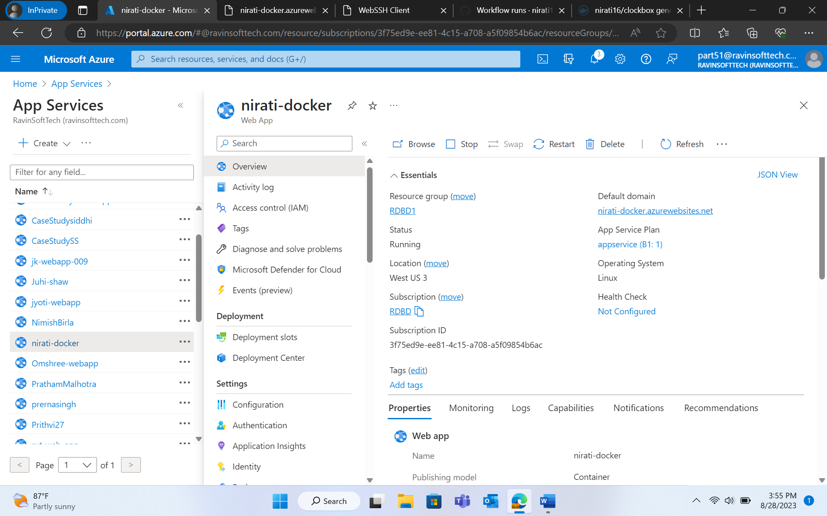

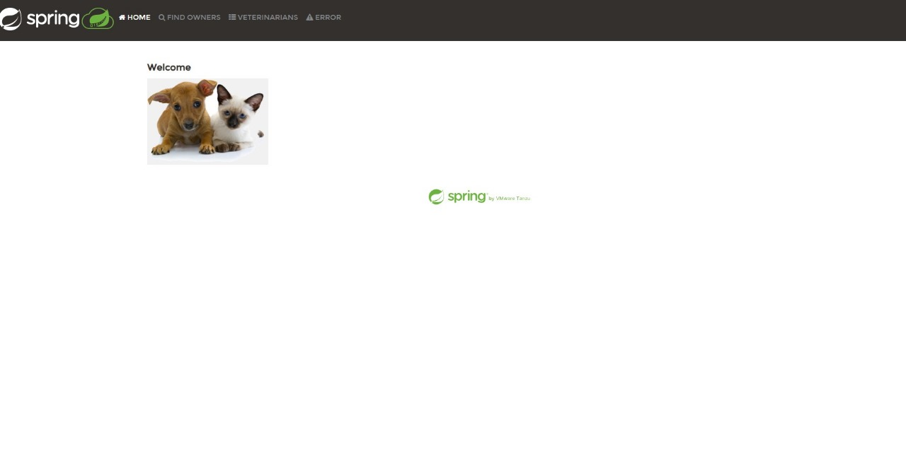

**GITHUB ACTIONS**

* *Step 01:* Creating the repository
  + Create a new GitHub repository using <https://github.com/dvdksn/clockbox/generate> template.
  + Open the Settings of repository > Secrets and variables > Actions.
  + Create new secret named DOCKERHUB_USERNAME and dockerID as value.
  + Create new PAT for DockerHub and name it as “clockboxci”.
  + Add PAT as second secret in GitHub repository, with the name as “DOCKERHUB_TOKEN”.
* *Step 02:* Setting up the workflow
* Click on Actions Tab in github repository.
* Select “Set up a workflow yourself”.
* Complete the yaml file.
* *Step 03:* Defining the workflow steps. Then, select “Commit changes” and push the changes to the main branch. Go to Actions tab. It displays the workflow.

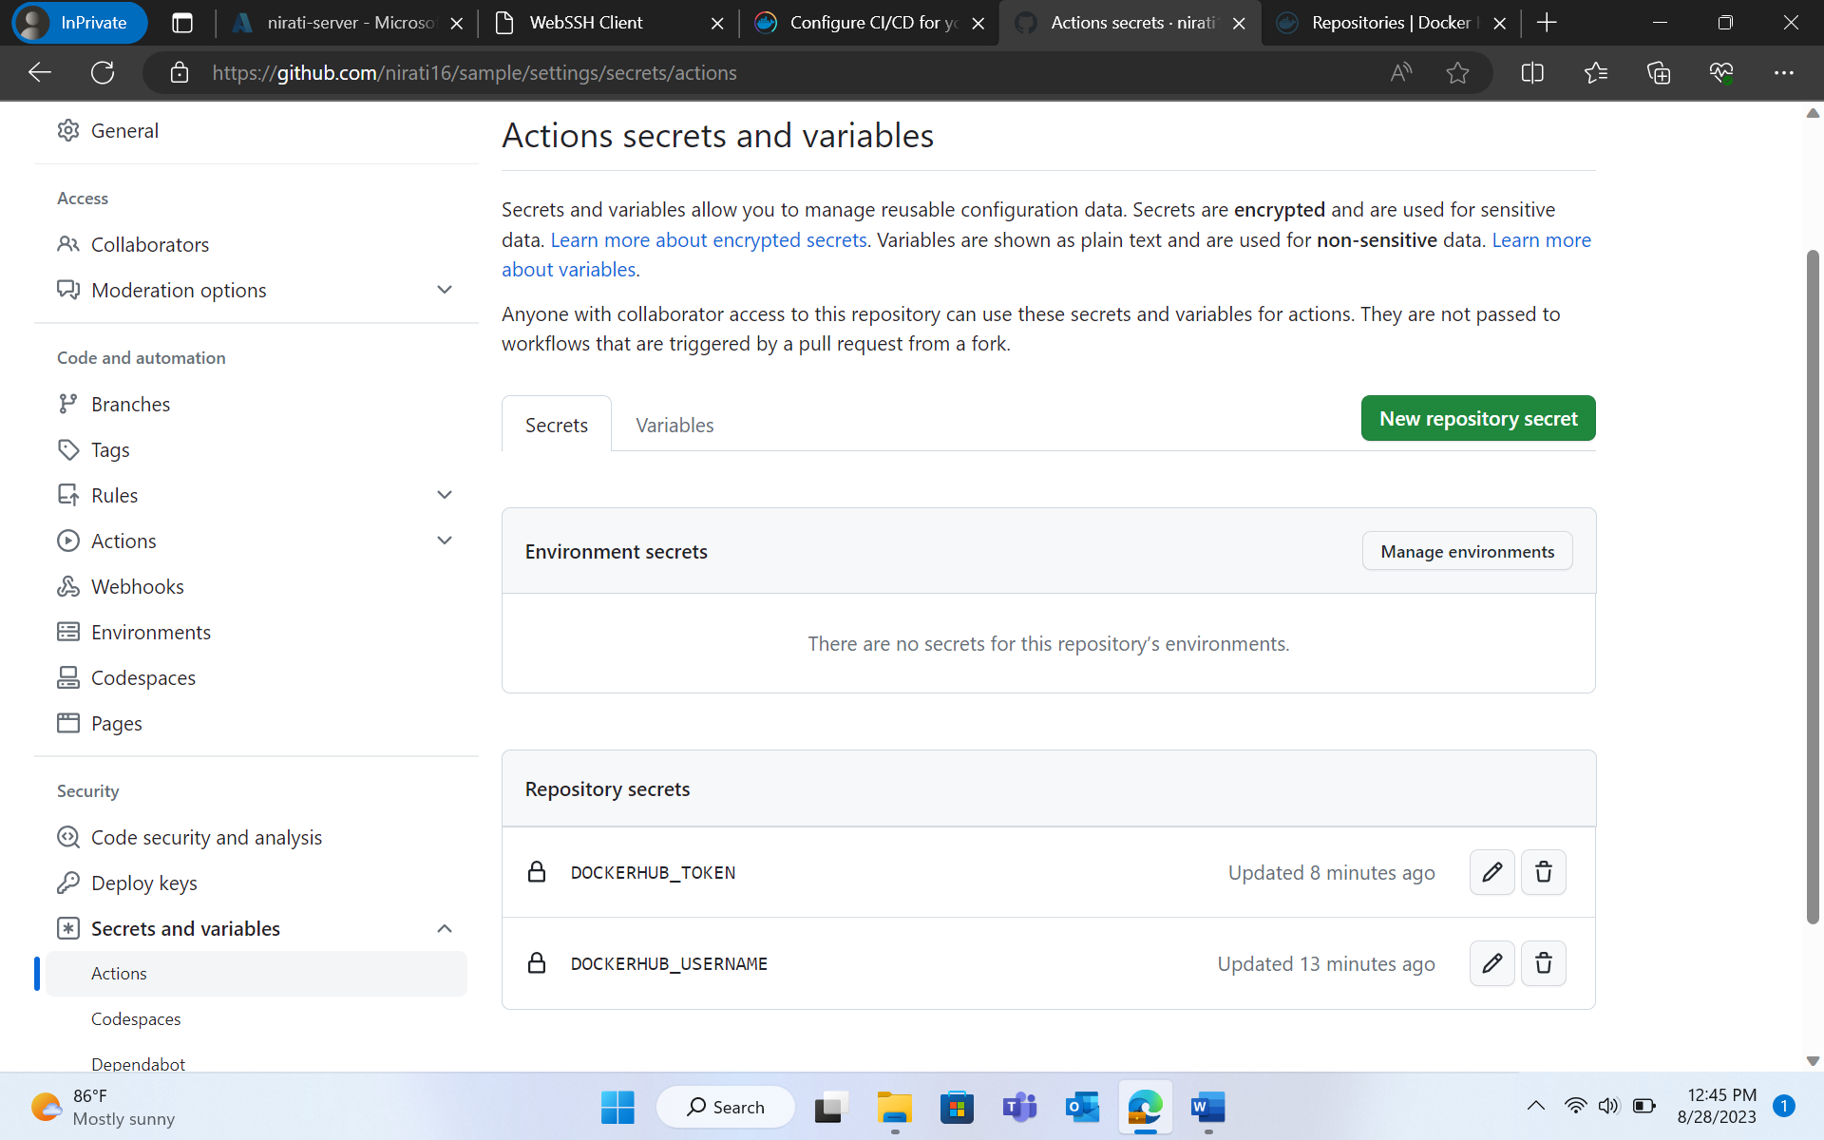

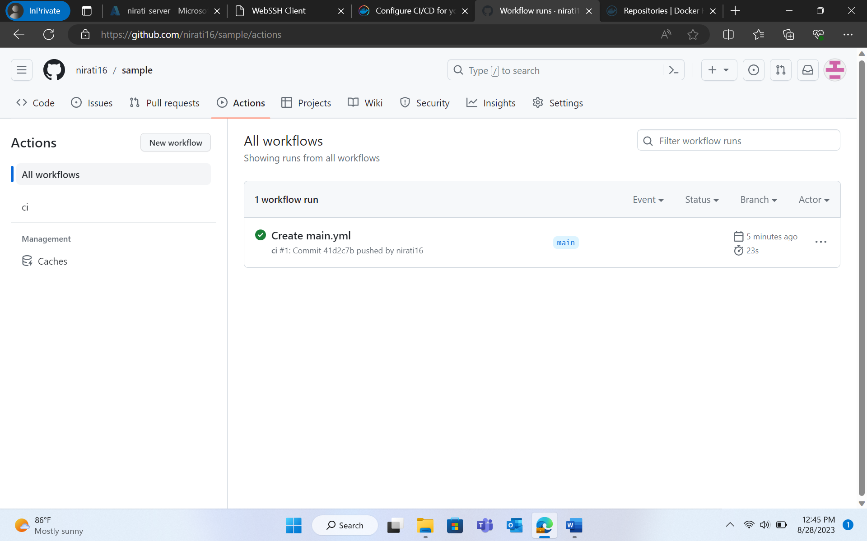

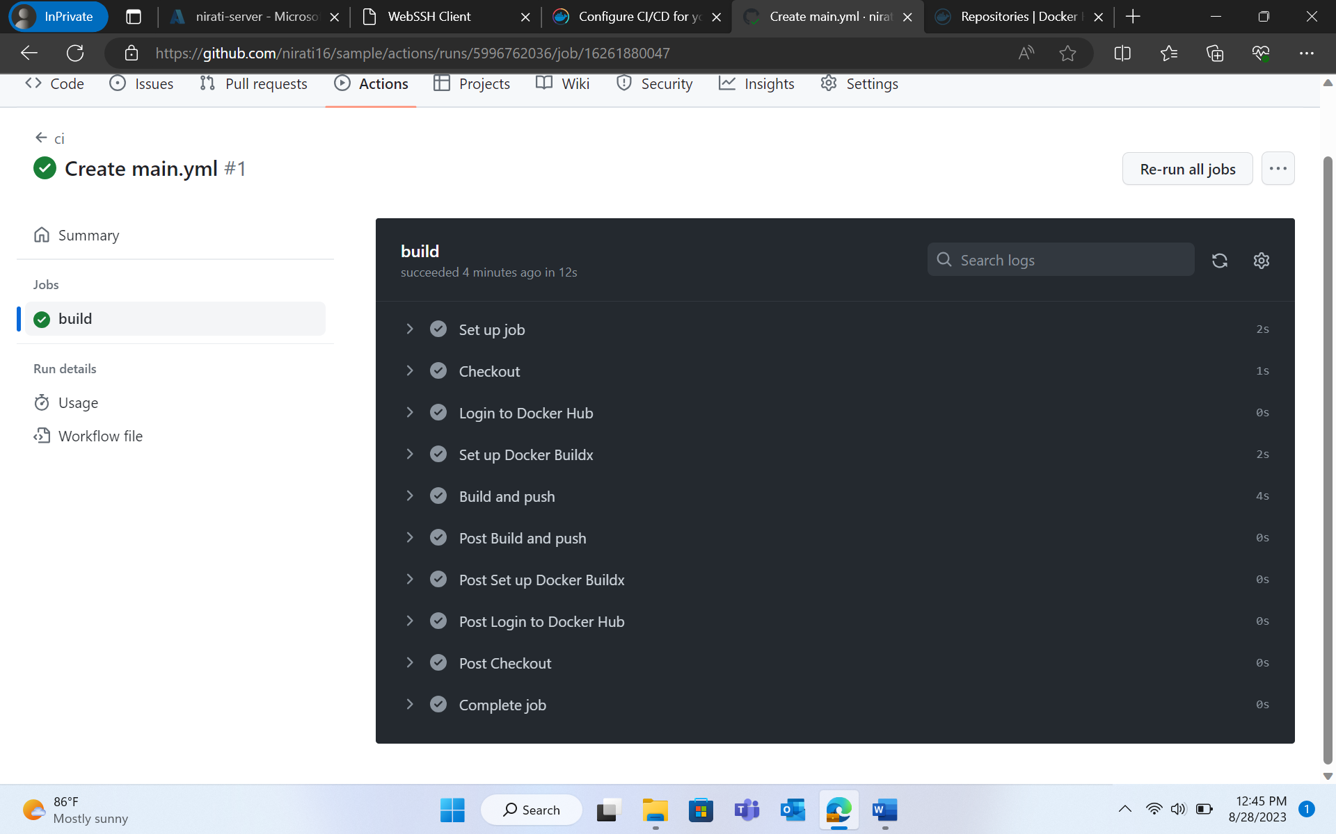

While installing maven, we encountered that our machine has java 11 but we require java 17. Following command is to be used to install java 17:

apt install openjdk-17-jdk openjdk-17-jre